**SERVERLESS EC2 INSTANCES SCHEDULING**

In some companies, there is no need to run their EC2 instances 24/7, they require instances to operate during specific time, During company working hours from 9:00 AM in the morning to 5:00 PM in the evening. To address this scenario, I will implement two Lambda functions responsible for starting and stopping instances. These Lambda functions will be triggered by CloudWatch Events in the morning and evening. This solution is fully serverless.

**ARCHITECTURE OF THE PROJECT**

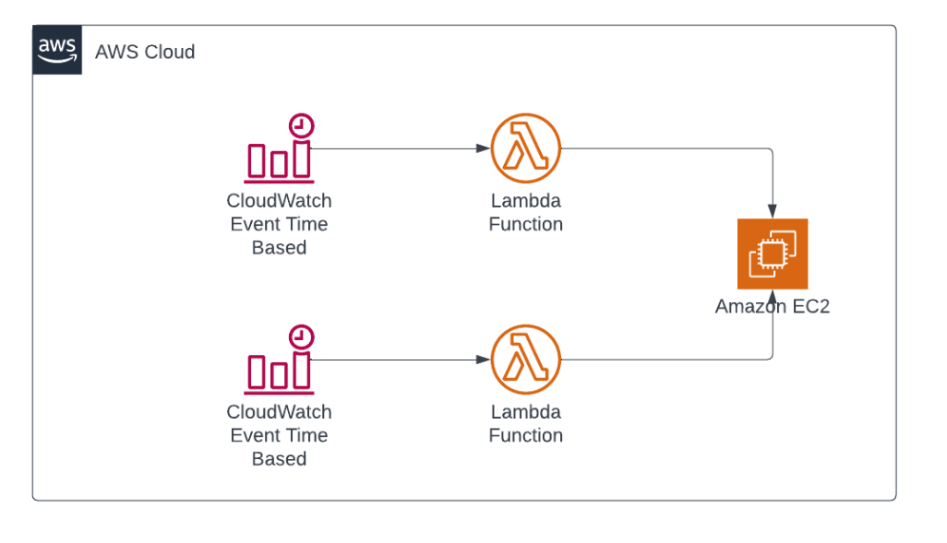

**STEP 1**

* Create an EC2 instance for the lambda function to start and stop.

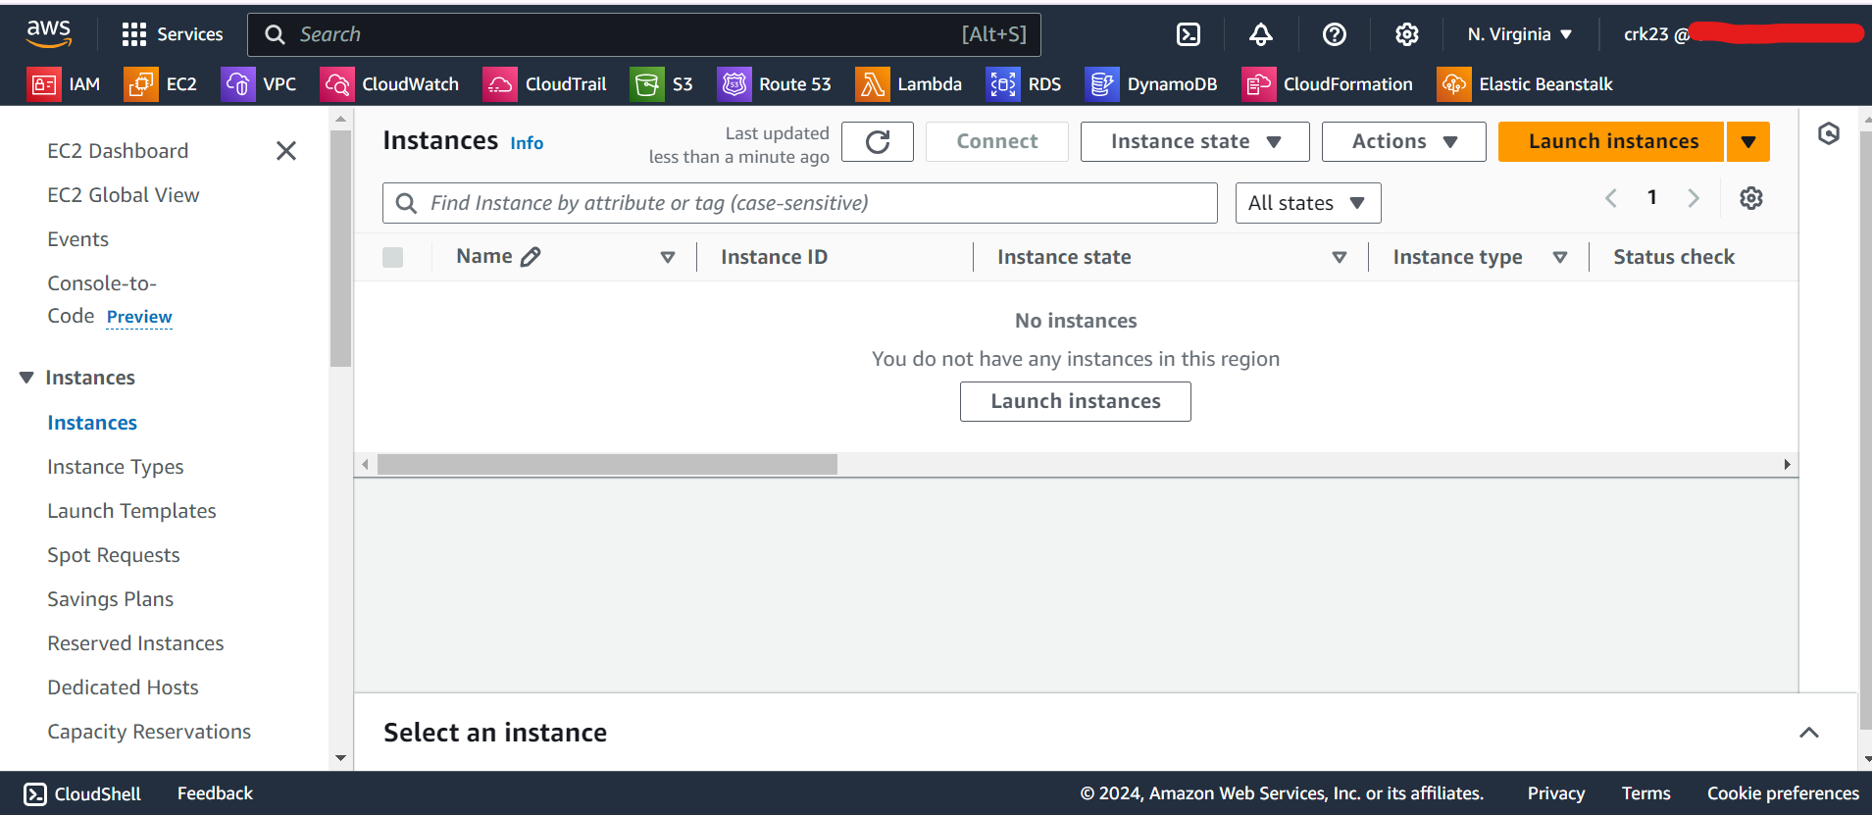

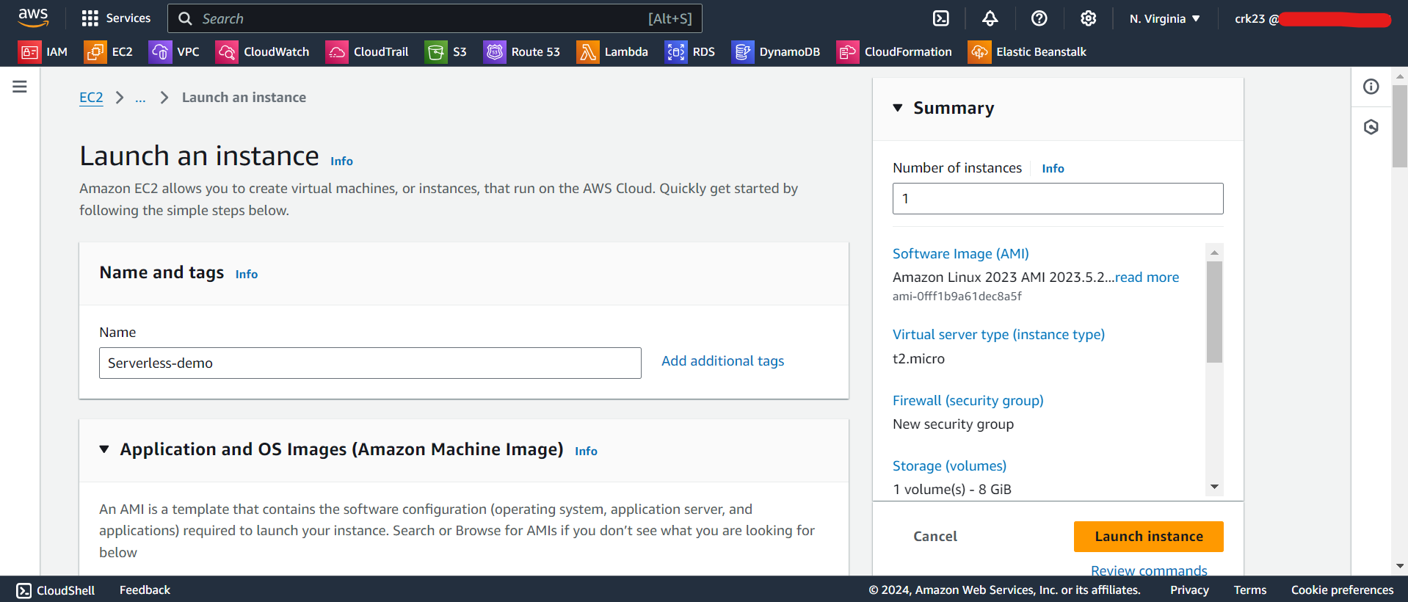

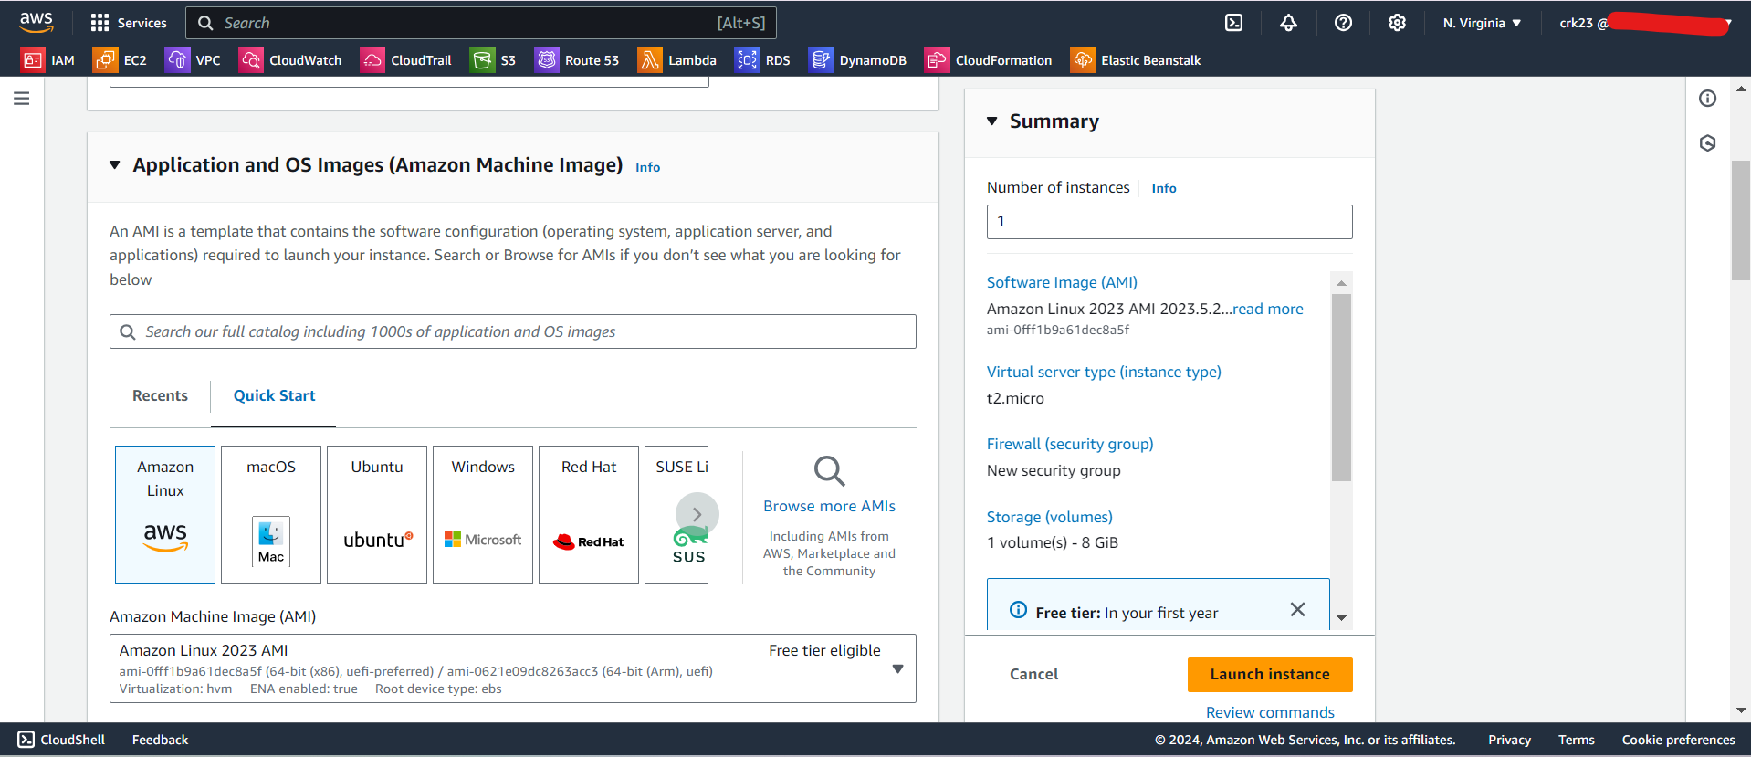

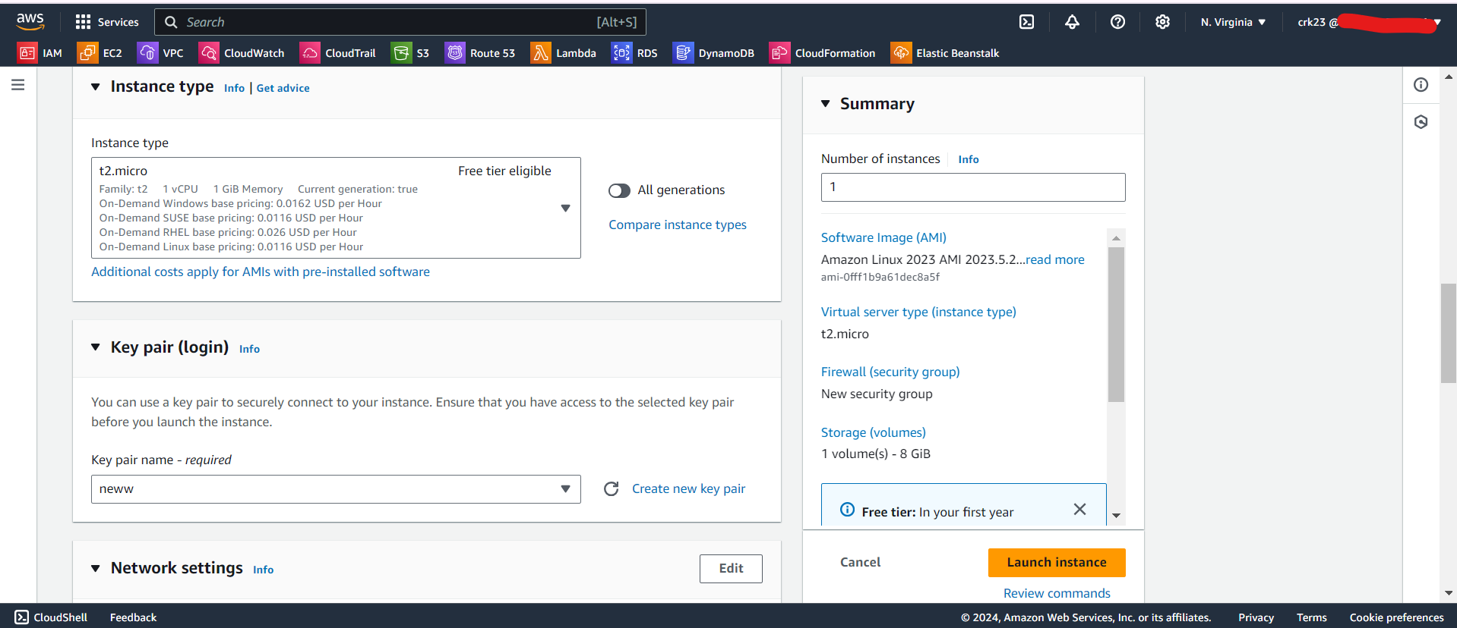

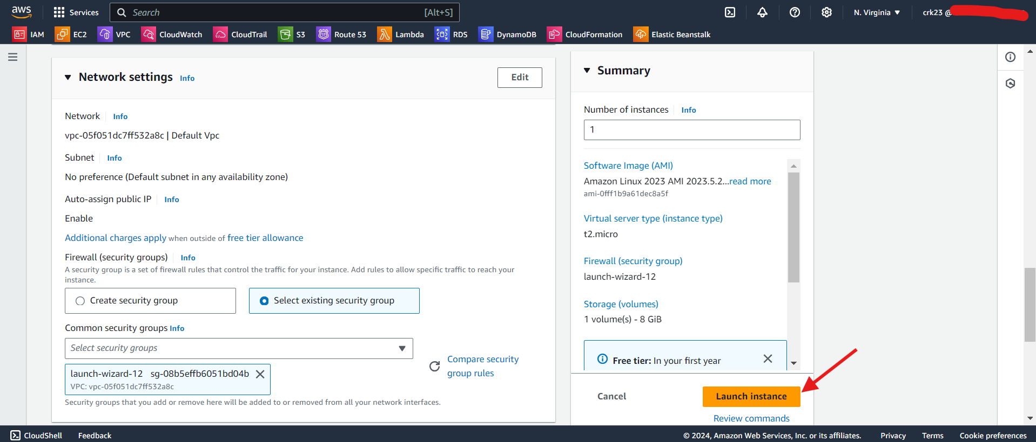

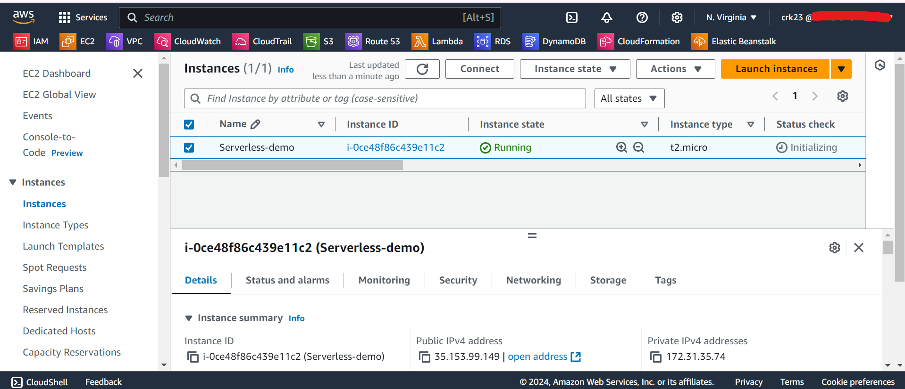

**STEP 2**

* Create a IAM policy for the lambda function.
* Select **services** as **EC2** and **Actions** as **Start Instances & Describe Instances** for starting the instances.

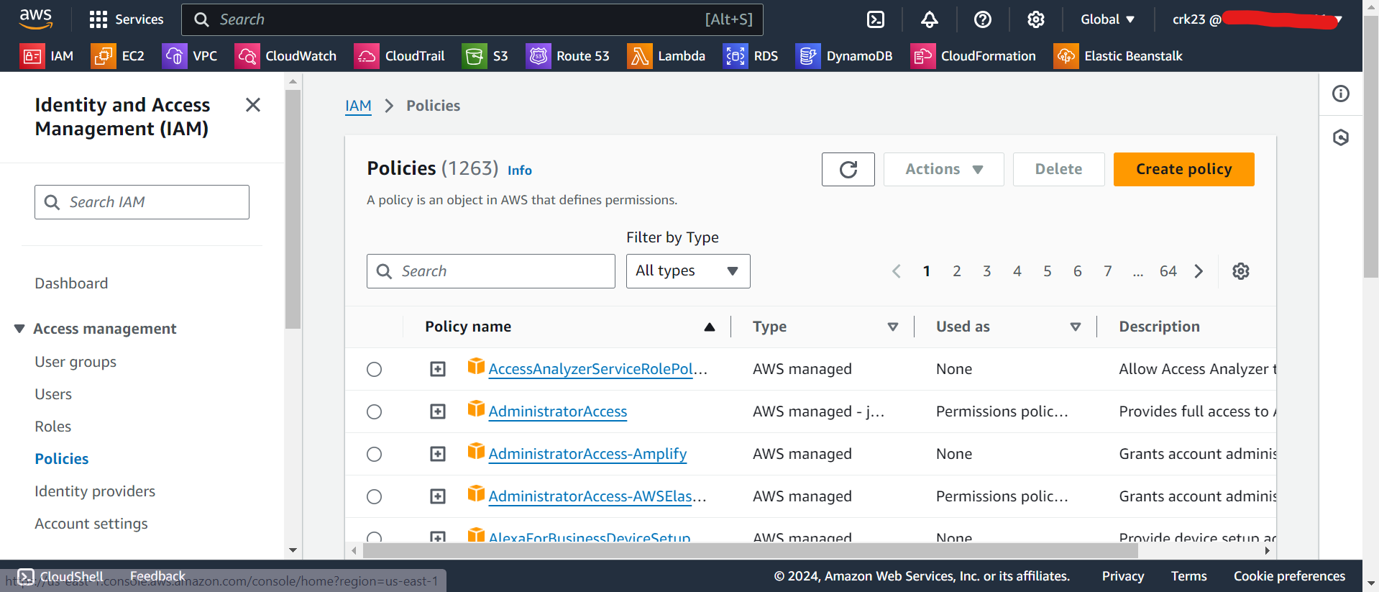

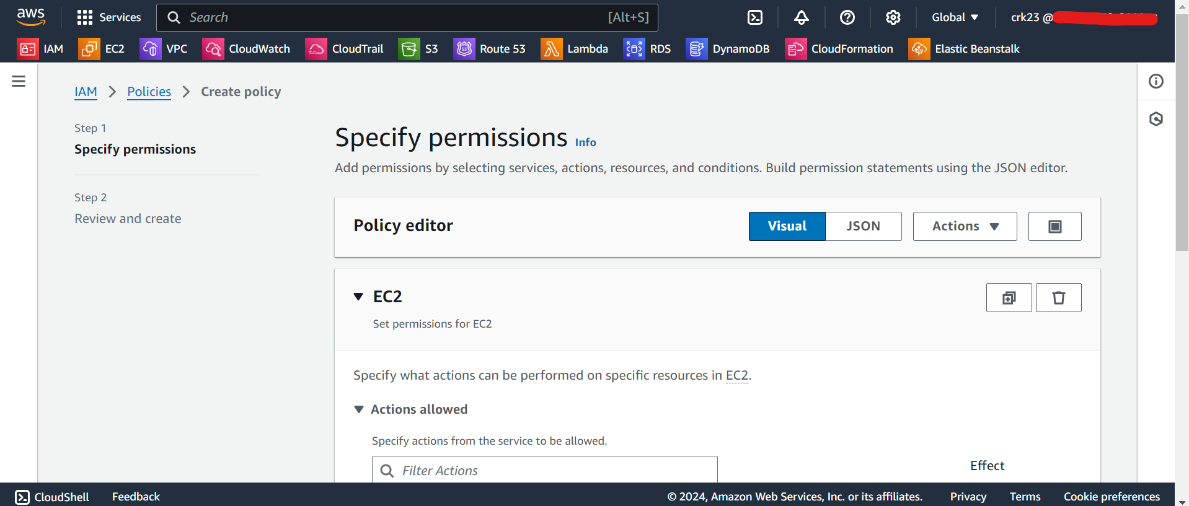

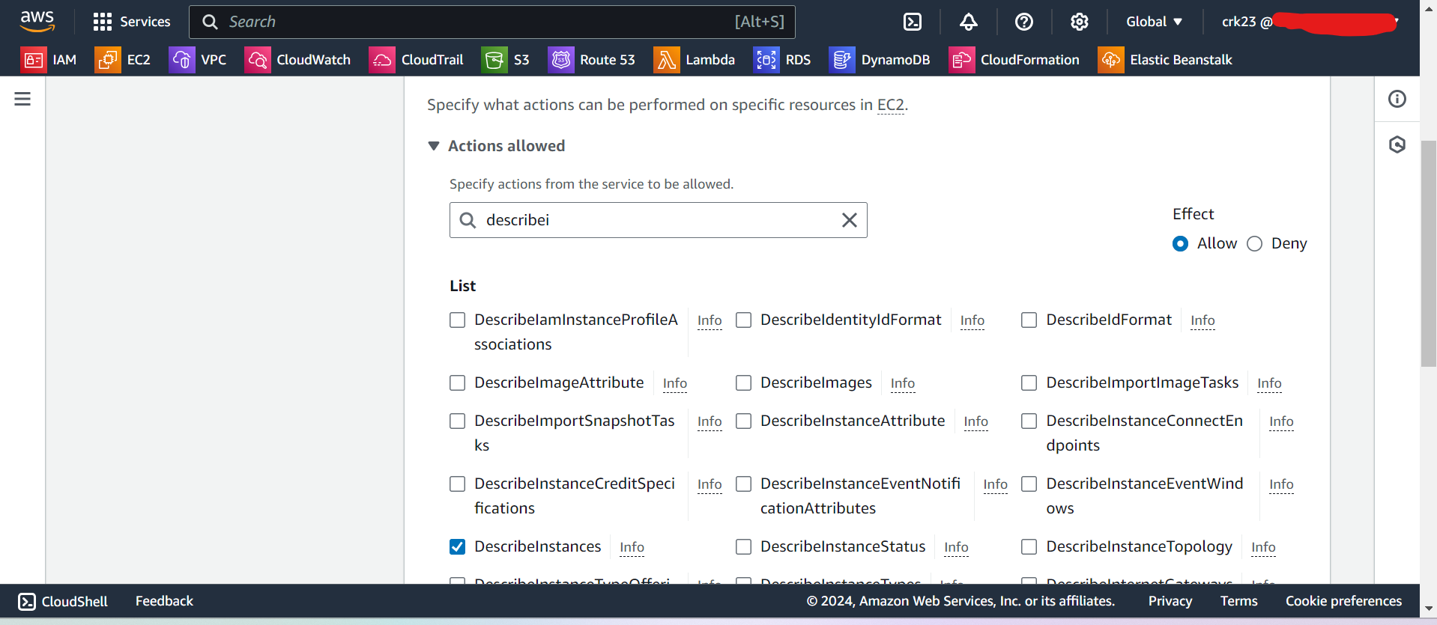

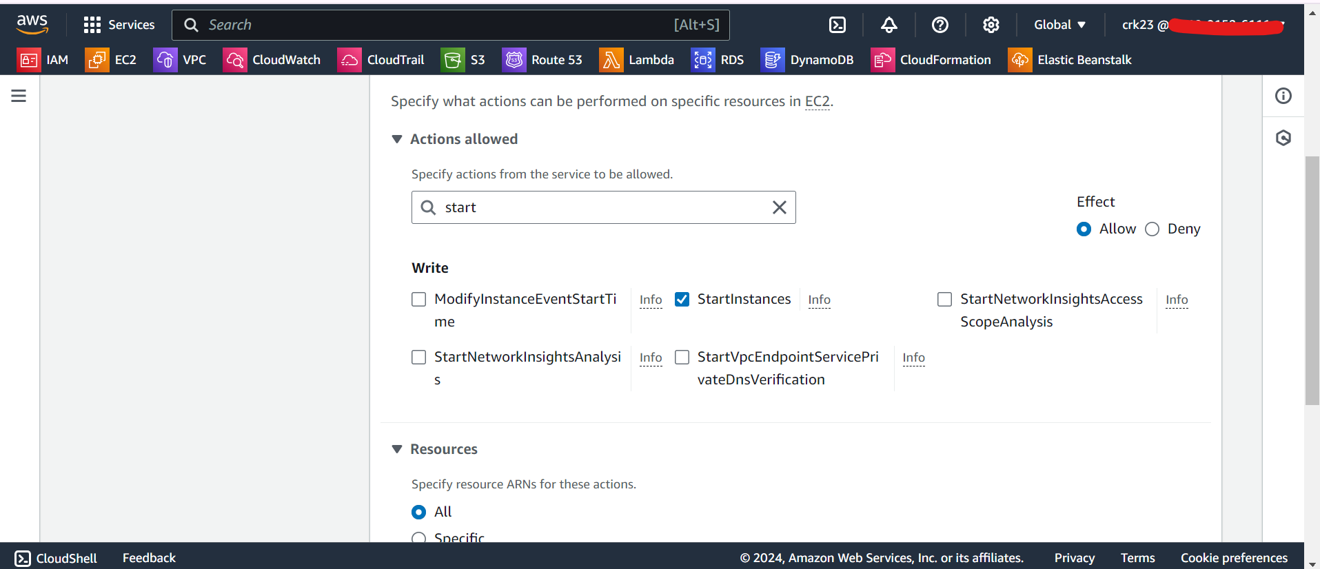

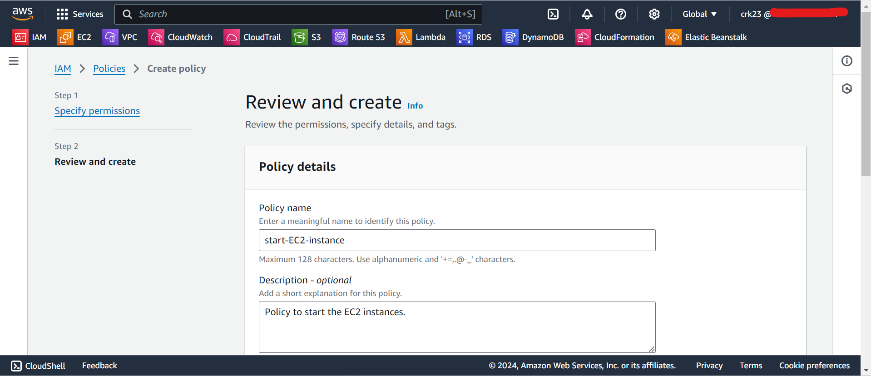

* Select **services** as **EC2** and **Actions** as **Stop Instances & Describe Instances** for stopping the instances.
* We are creating two lambda functions for starting an stopping the instances.
* **Start-EC2** function will have **Role Name:** **start-EC2-instance** policy attached to the role.
* **Stop-EC2** function will have **Role Name: stop-EC2-instance** policy attached to the role.

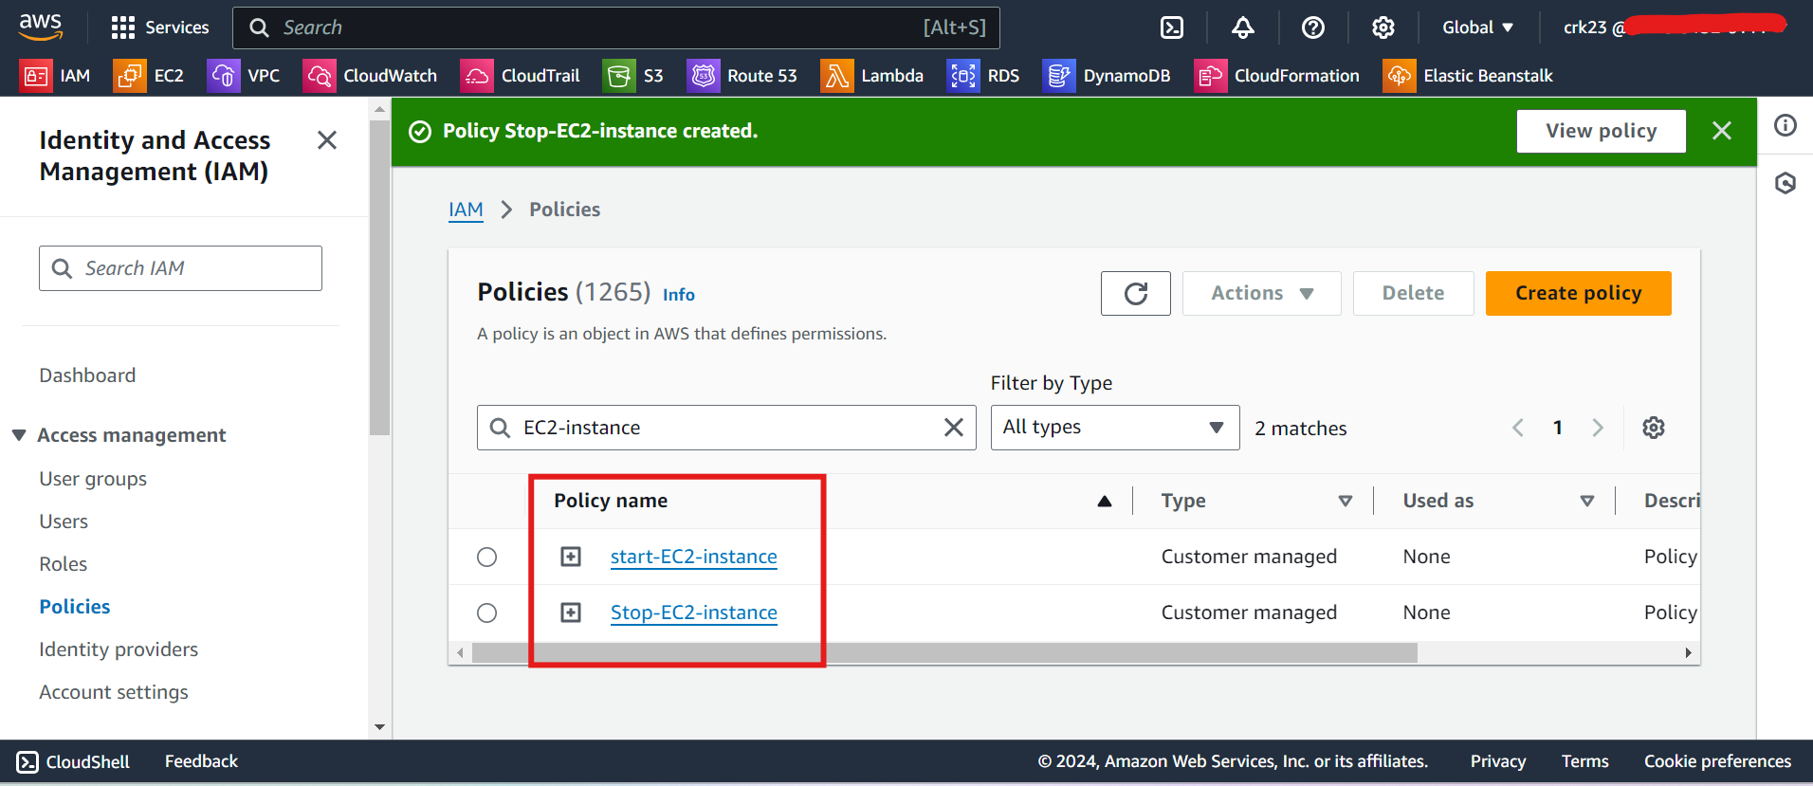

**STEP 3**

* Go to the Lambda Console.
* Select **python**(Select latest version) as the runtime and other as defaults.

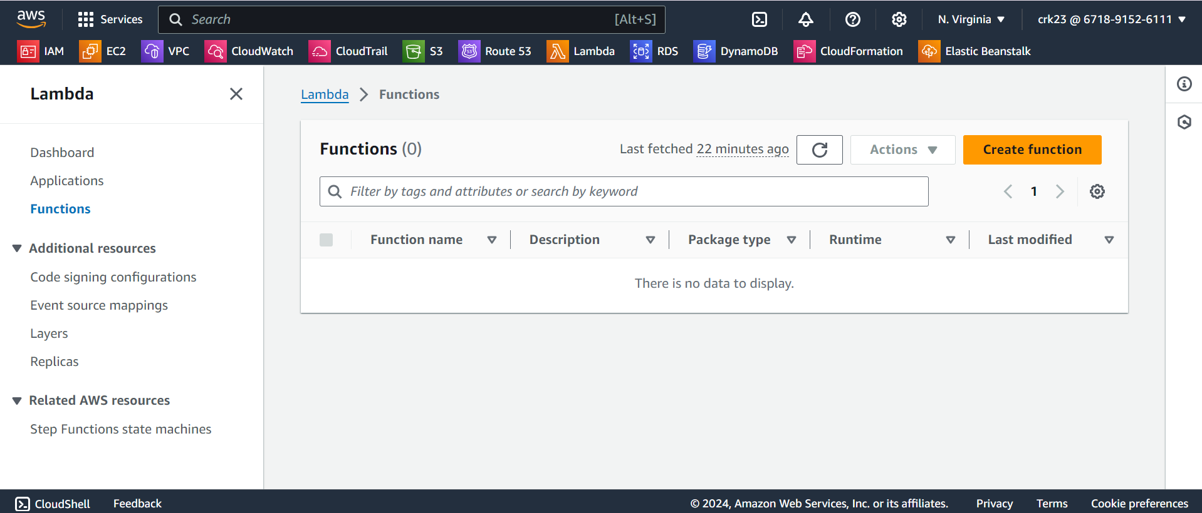

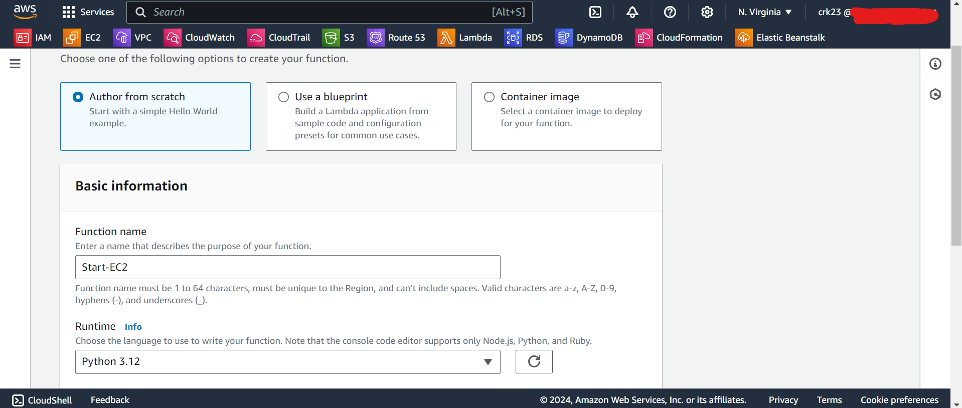

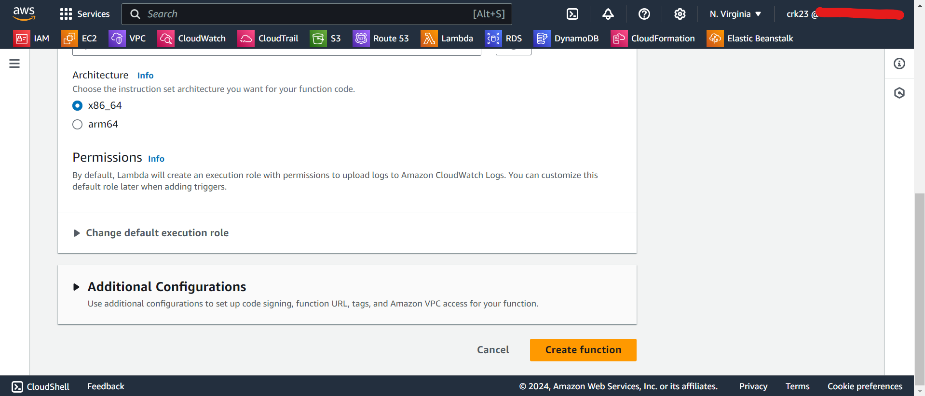

* Paste the below python code in the default function and replace the region and the instance id.

**EC2-instance-start.py**

import boto3

def lambda_handler(event, context):

# Initialize the EC2 client

ec2_client = boto3.client('ec2', region_name=us-east-1') # Replace your Region name

# Specify the instance ID of the EC2 instance you want to start

instance_id = 'i-***********' # Replace your Own Instance ID

# Start the EC2 instance

try:

response = ec2_client.start_instances(InstanceIds=[instance_id], DryRun=False)

print(f"Starting EC2 instance {instance_id}...")

print(f"Response: {response}")

return {

'statusCode': 200,

'body': f"EC2 instance {instance_id} is being started."

}

except Exception as e:

print(f"Error starting EC2 instance: {e}")

return {

'statusCode': 500,

'body': f"Error starting EC2 instance: {str(e)}"

}

* Deploy the function

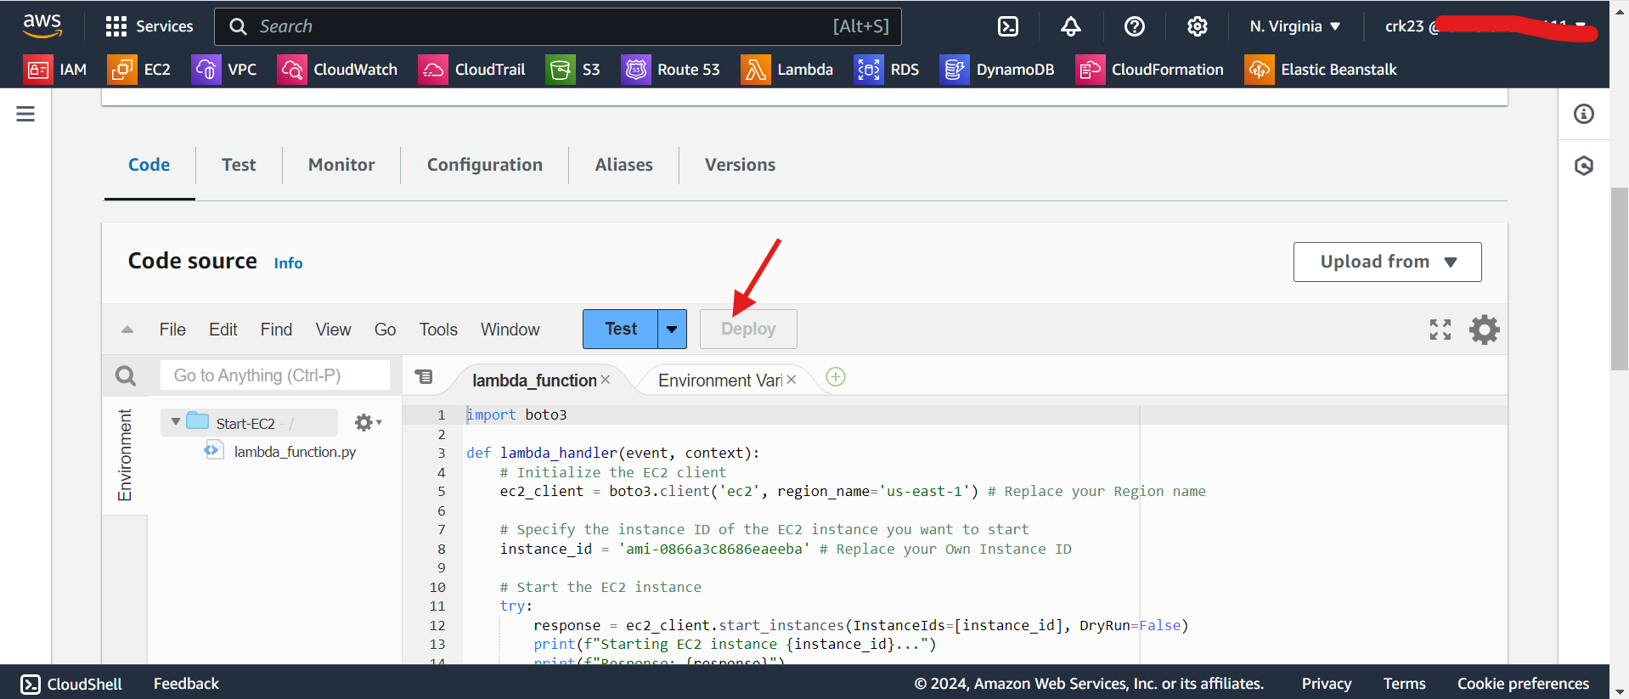

* Select configuration and increase the timeout

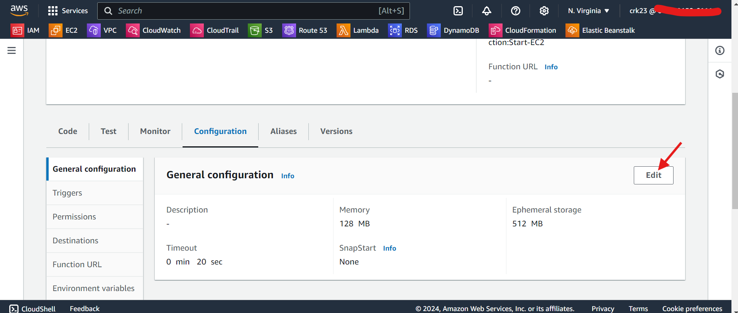

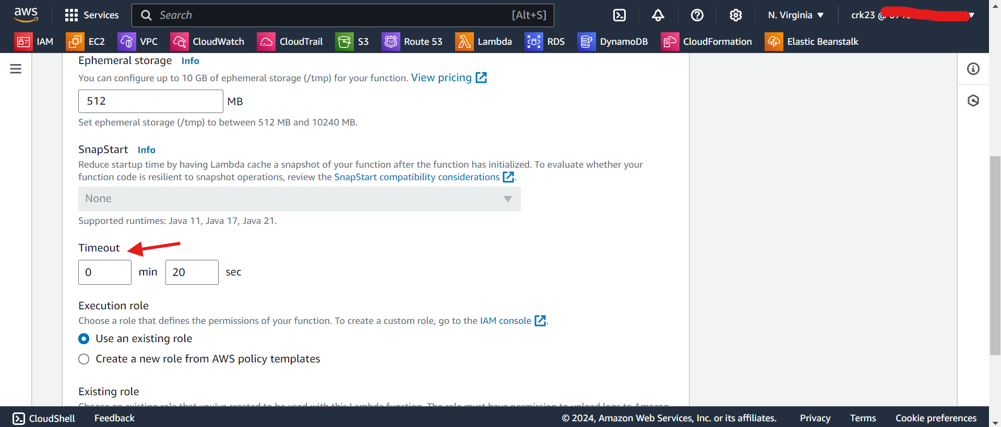

* Test the function

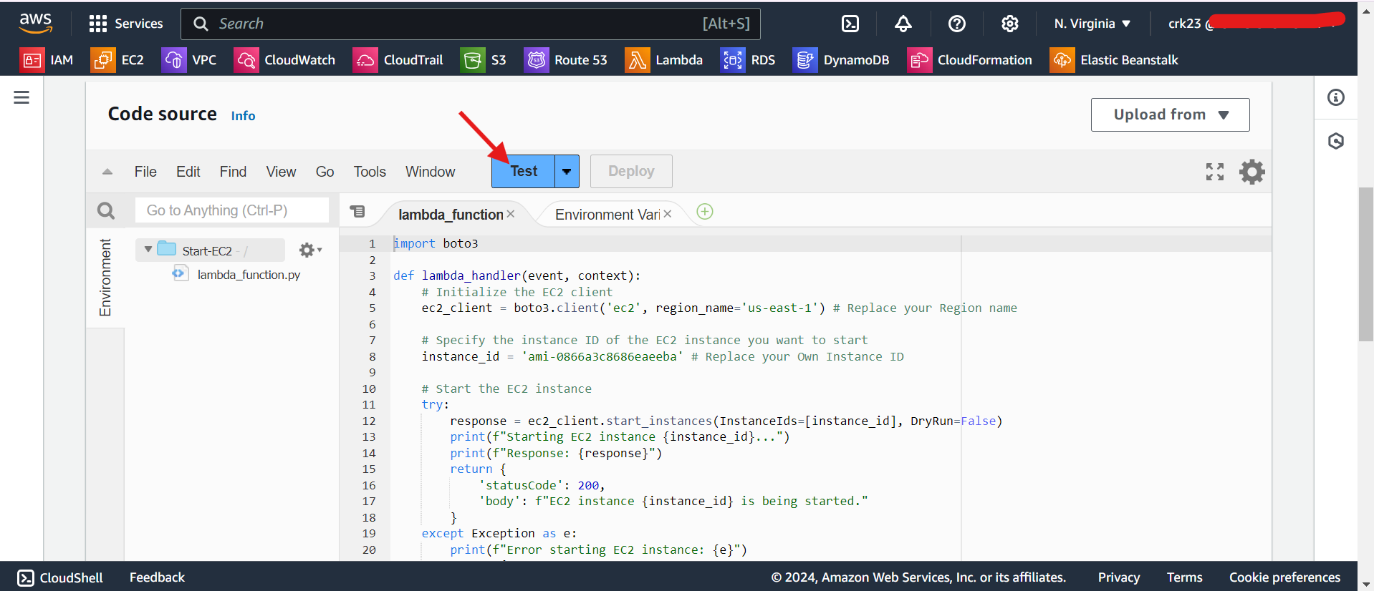

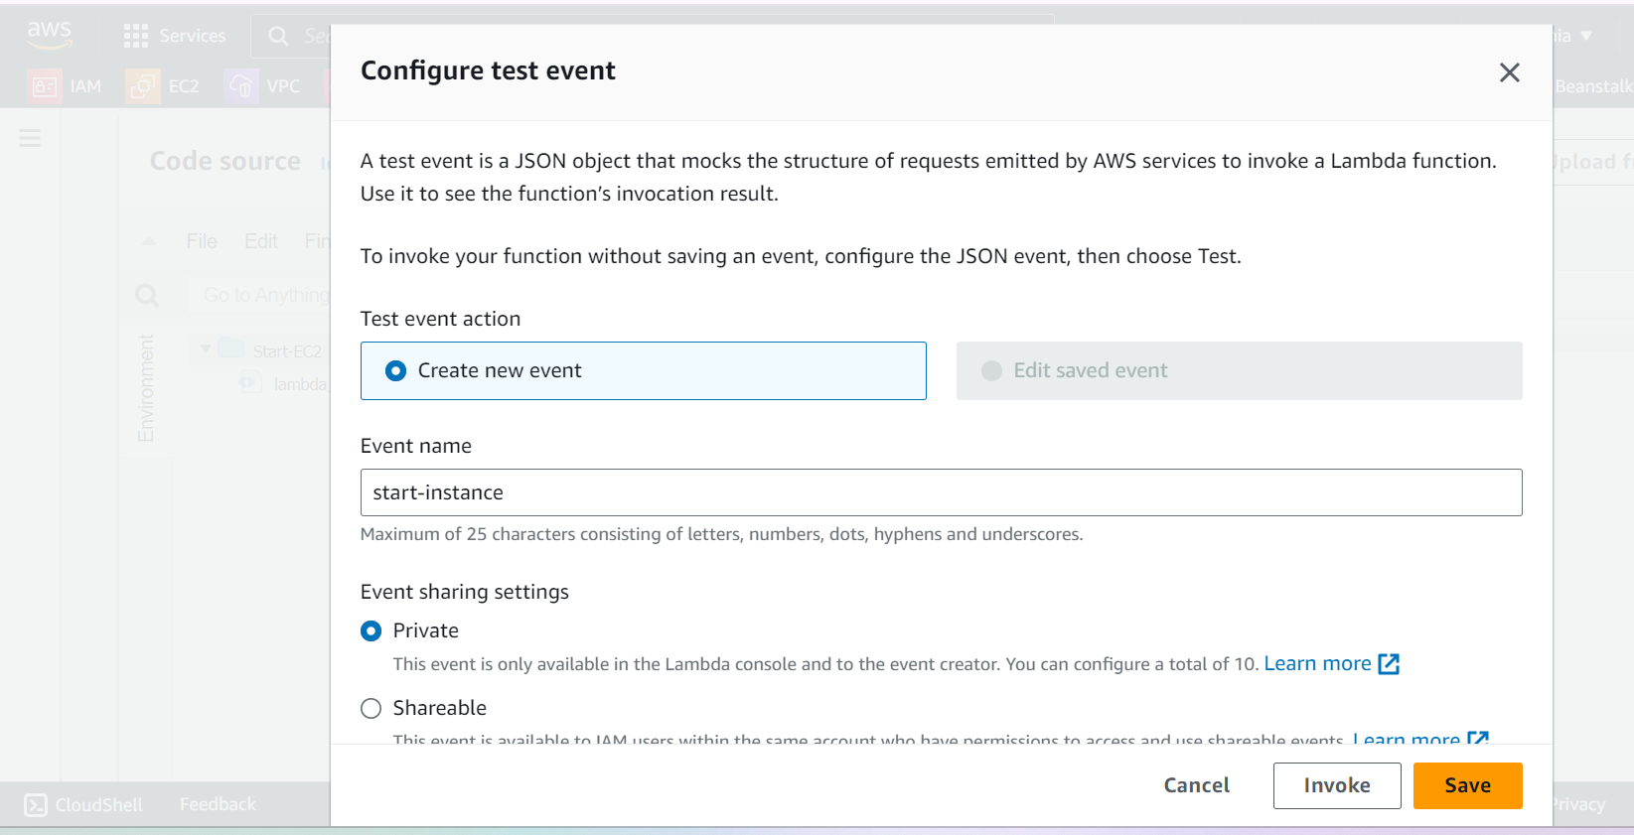

* Select the **Configuration > Permissions**. Select the Execution role and attach theStart-EC2-instance policy to this role.

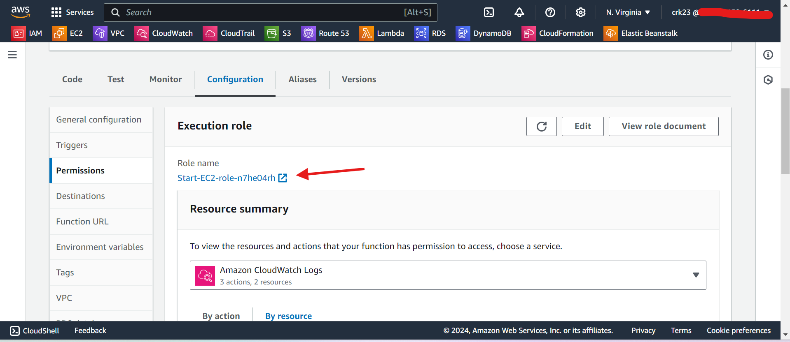

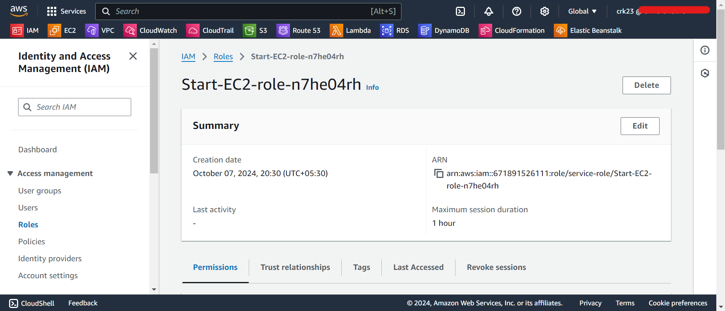

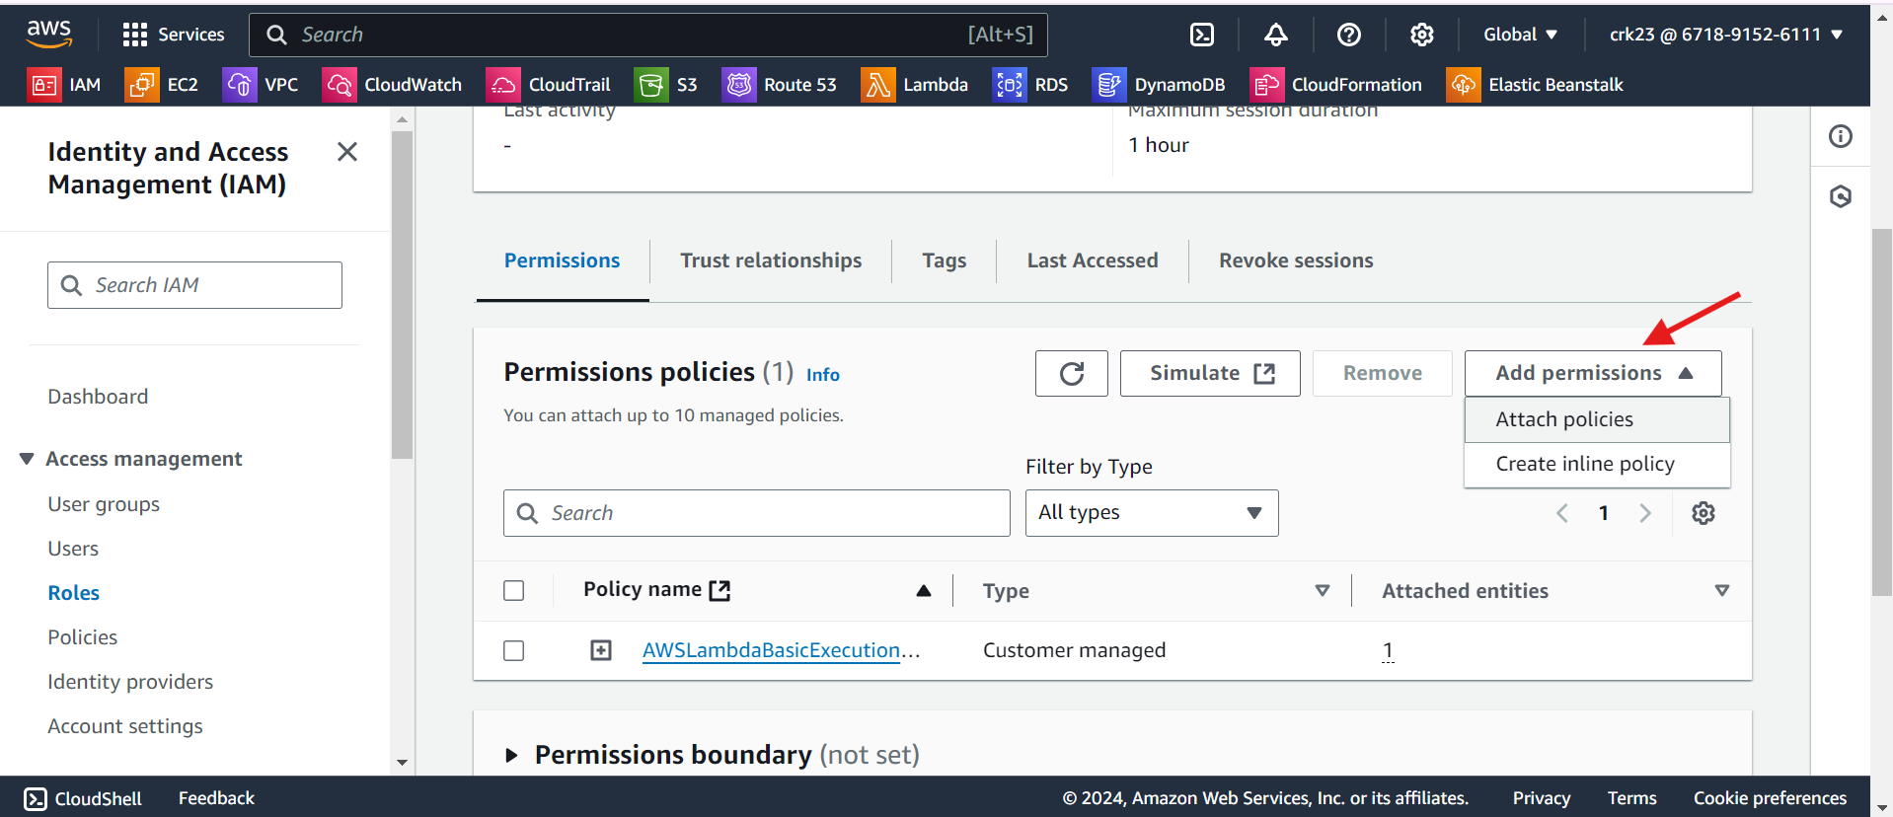

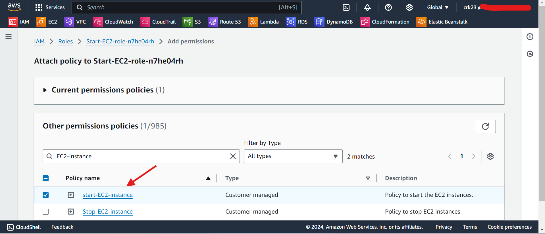

* Now test the lambda function
* We can see the instances is in Running state, If we need to test our lambda function you can manually stop the instance and test the function, It will start the instance.

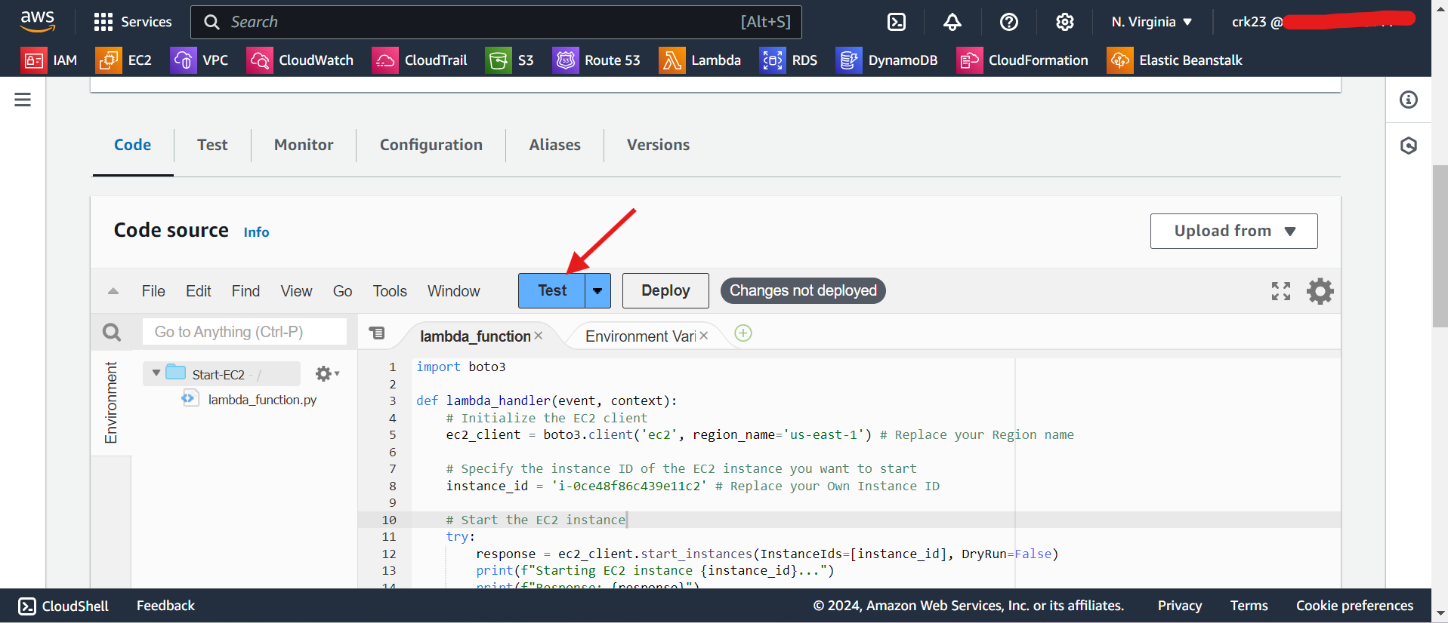

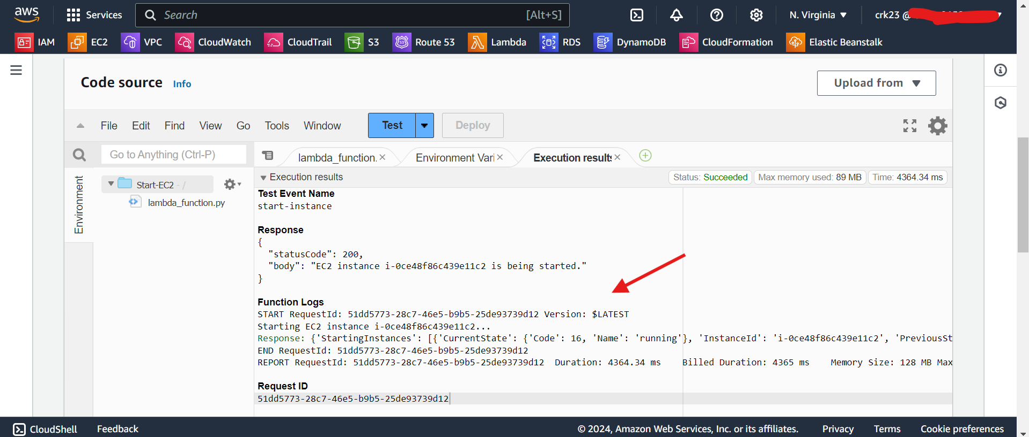

* Repeat the same steps followed for the creating a **start-EC2 function** to create function for creating **stop-EC2 function.**
* Replace the default function code with stop instance python code mentioned below
* Attach the **stop-EC2-instance** policy to the Execution role.

**EC2-instance-start.py**

import boto3

def lambda_handler(event, context):

# Initialize the EC2 client

ec2_client = boto3.client('ec2', region_name='us-east-1') # Replace your Region name

# Specify the instance ID of the EC2 instance you want to stop

instance_id = 'i-*******' # Replace your Own Instance ID

# Stop the EC2 instance

try:

response = ec2_client.stop_instances(InstanceIds=[instance_id], DryRun=False)

print(f"Stopping EC2 instance {instance_id}...")

print(f"Response: {response}")

return {

'statusCode': 200,

'body': f"EC2 instance {instance_id} is being stopped."

}

except Exception as e:

print(f"Error stopping EC2 instance: {e}")

return {

'statusCode': 500,

'body': f"Error stopping EC2 instance: {str(e)}"

}

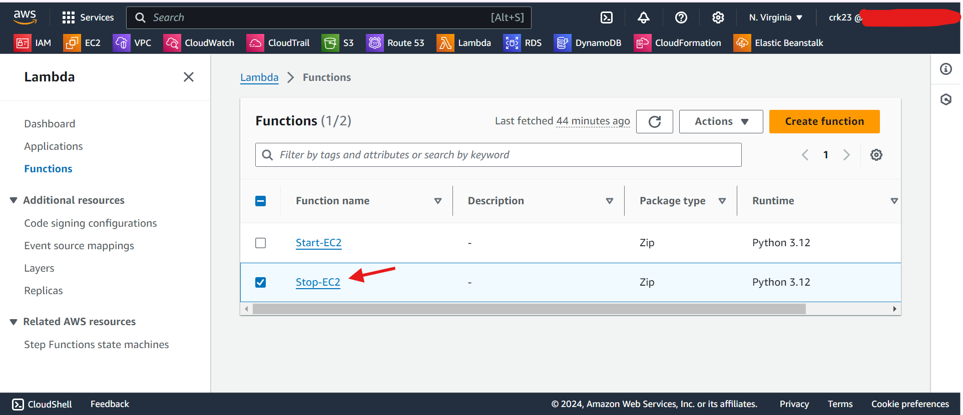

* Deploy and test the function.
* It runs successfully and stops the instance.

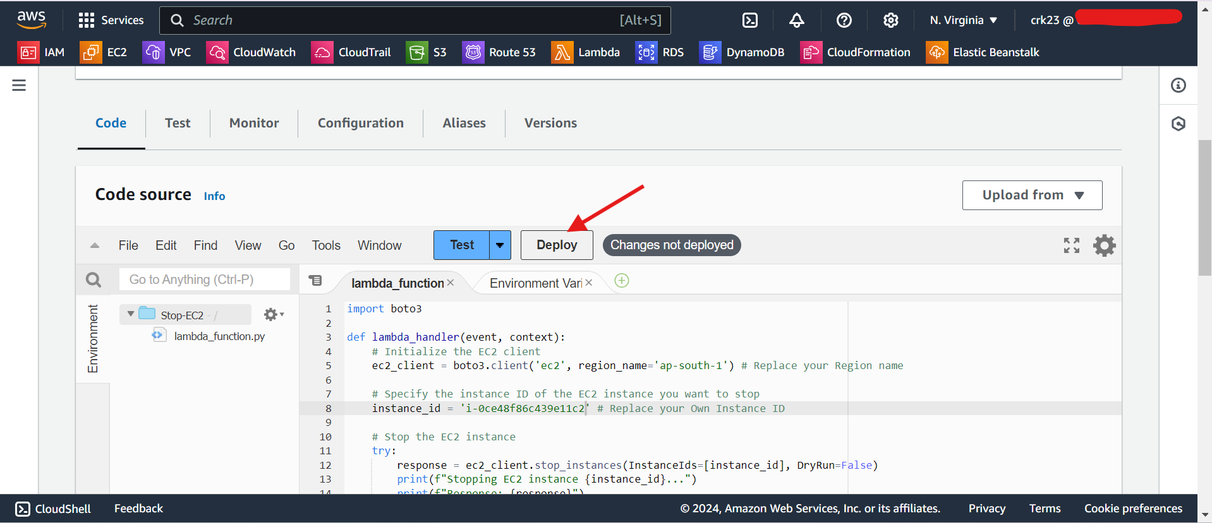

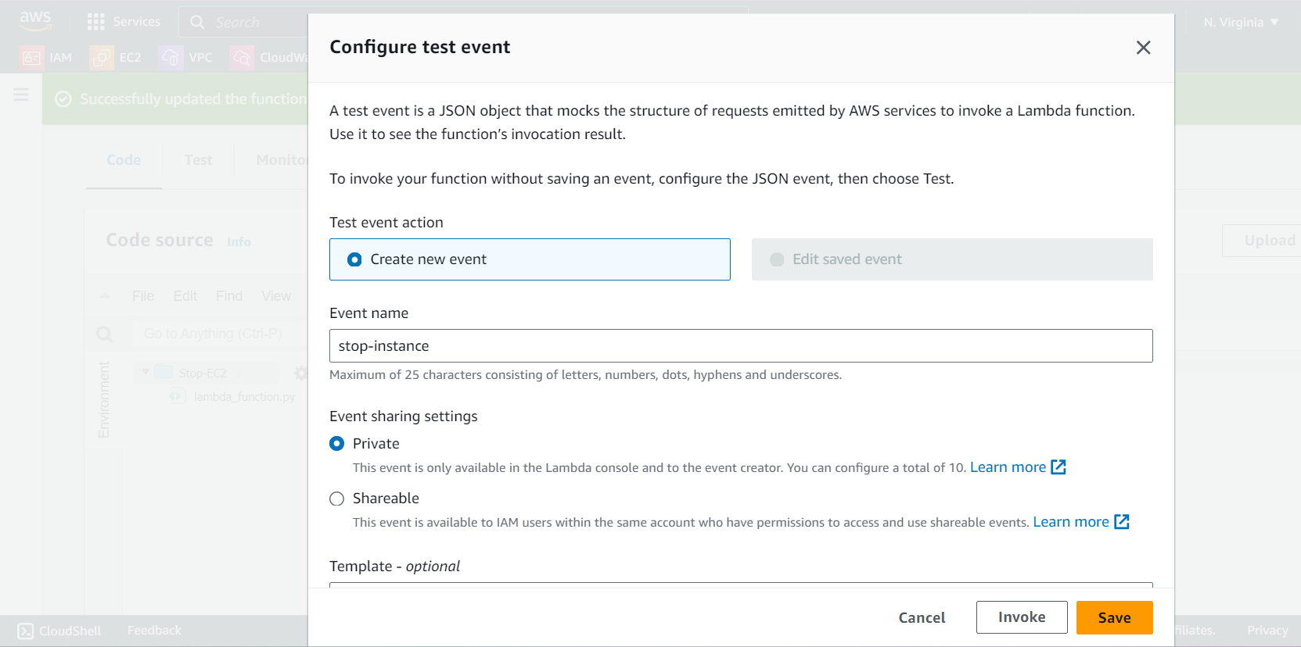

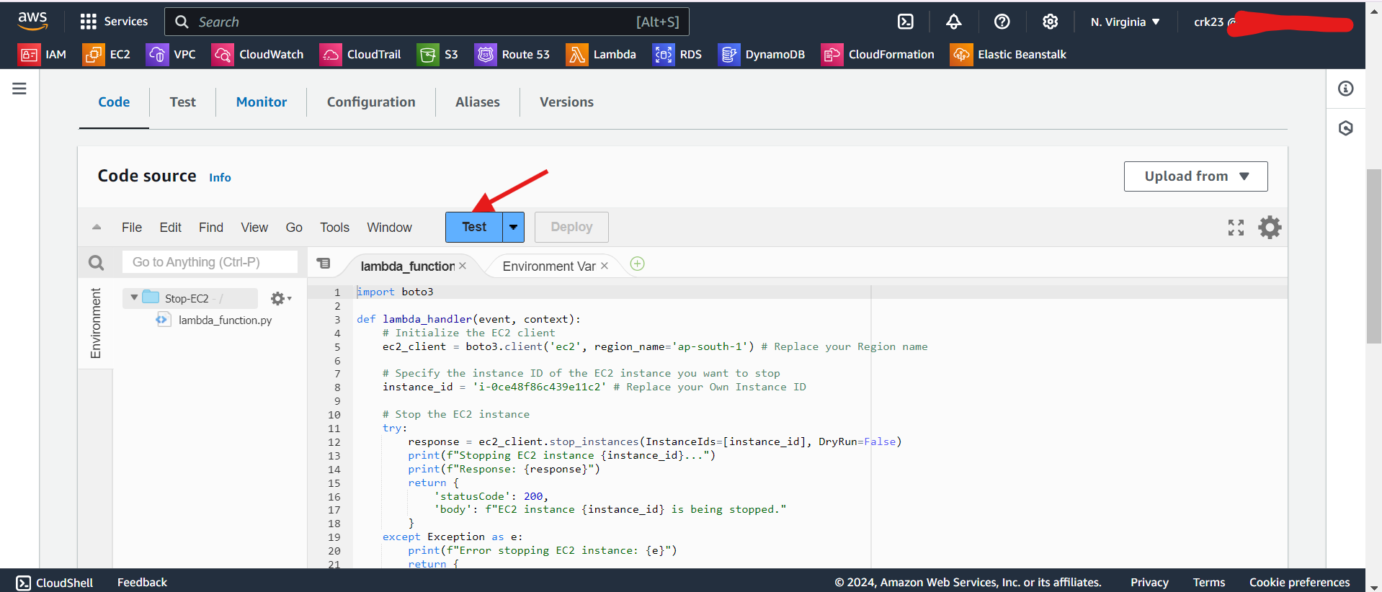

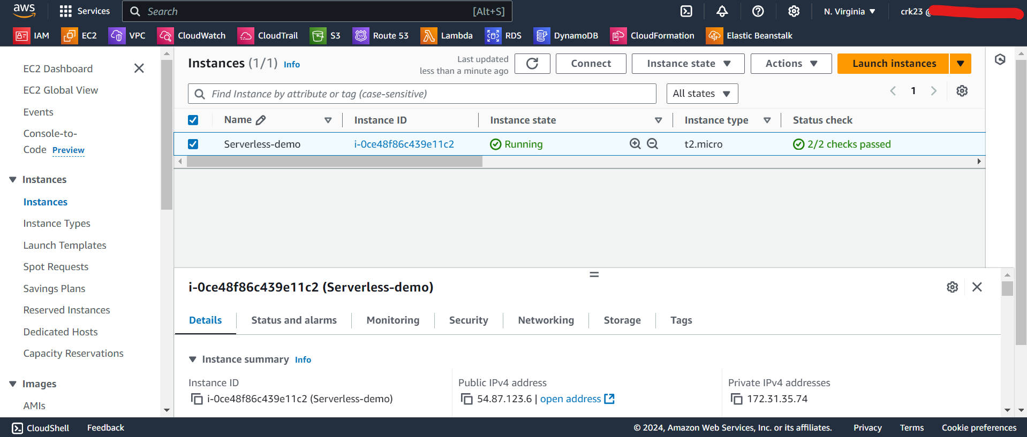

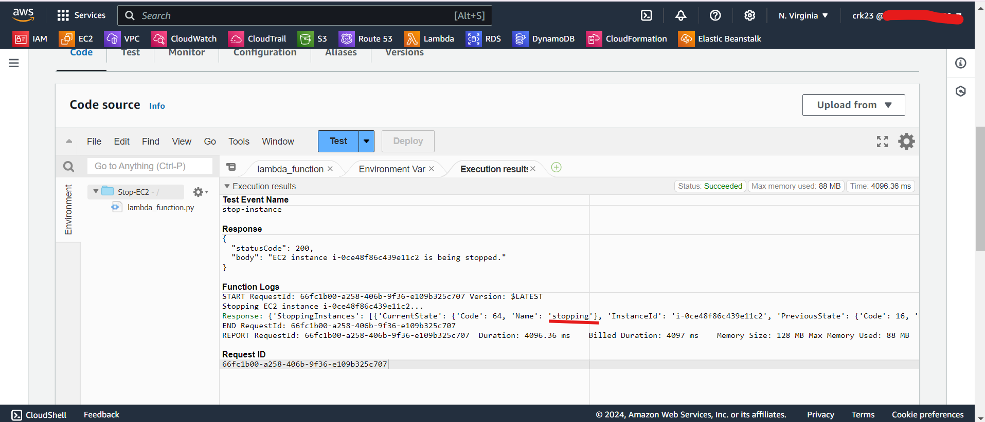

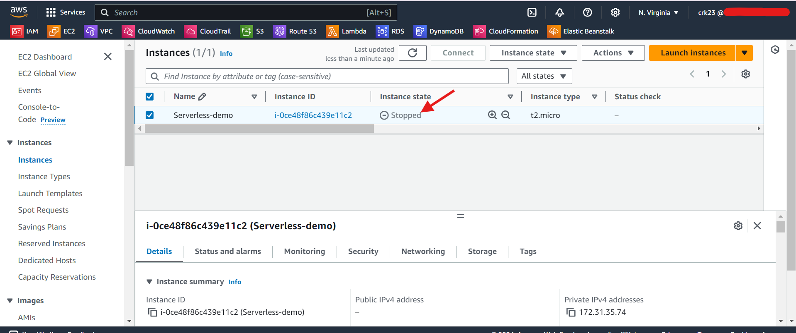

* Also check Start-EC2 if the stopped instance is starting after running the lambda function

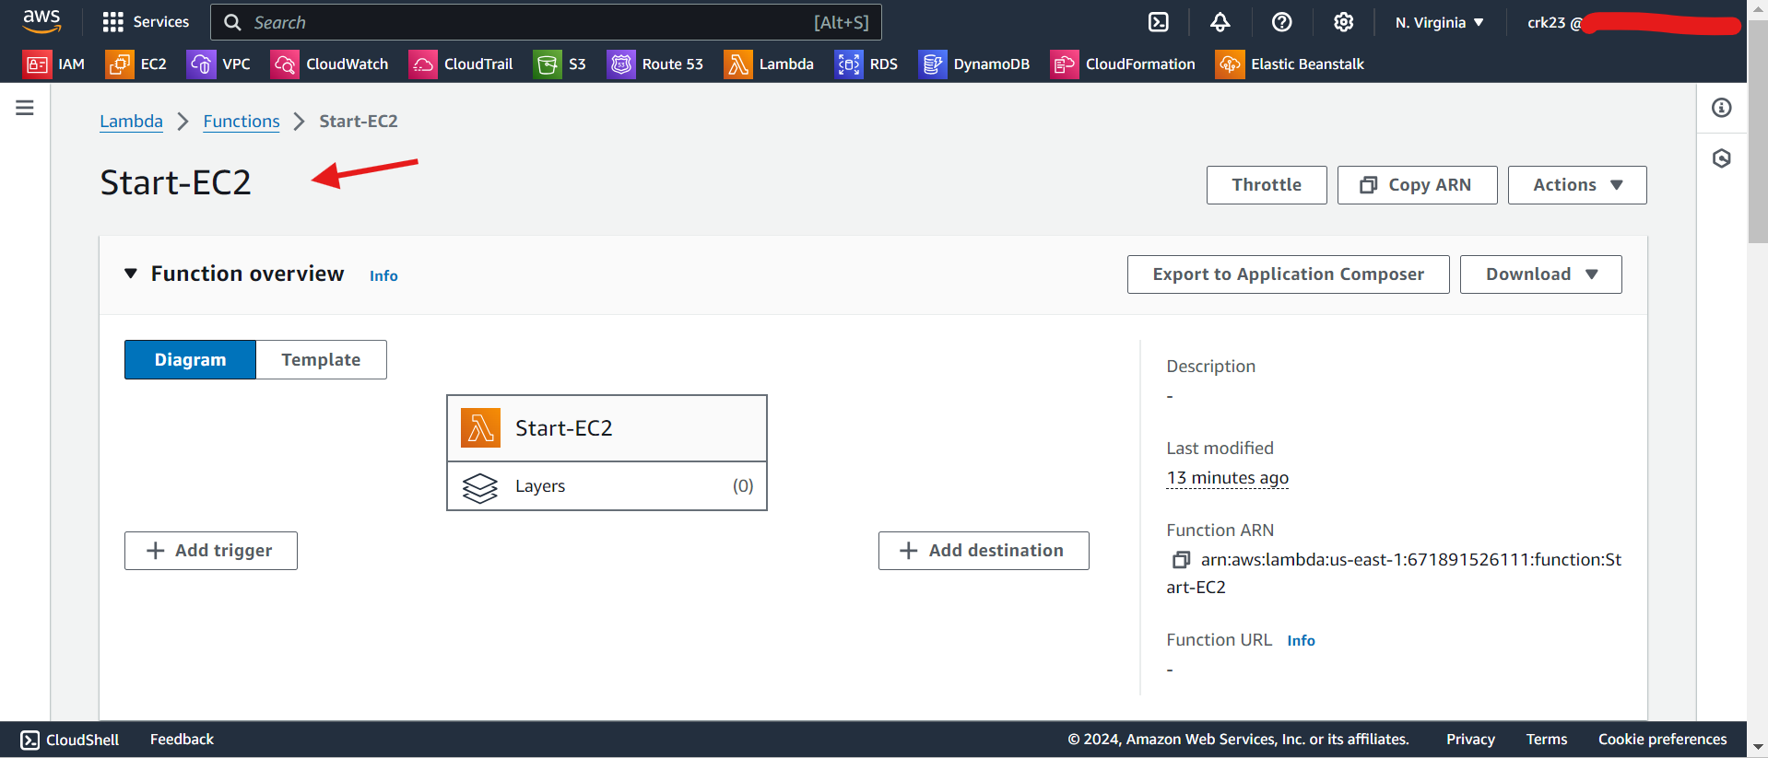

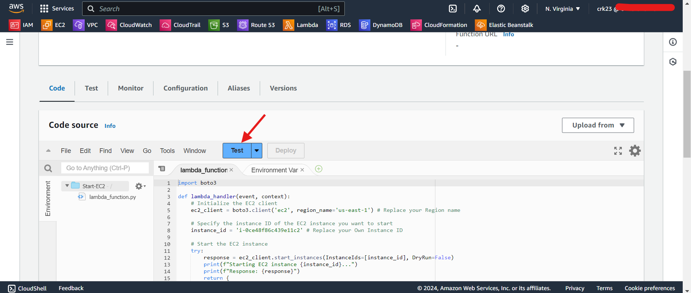

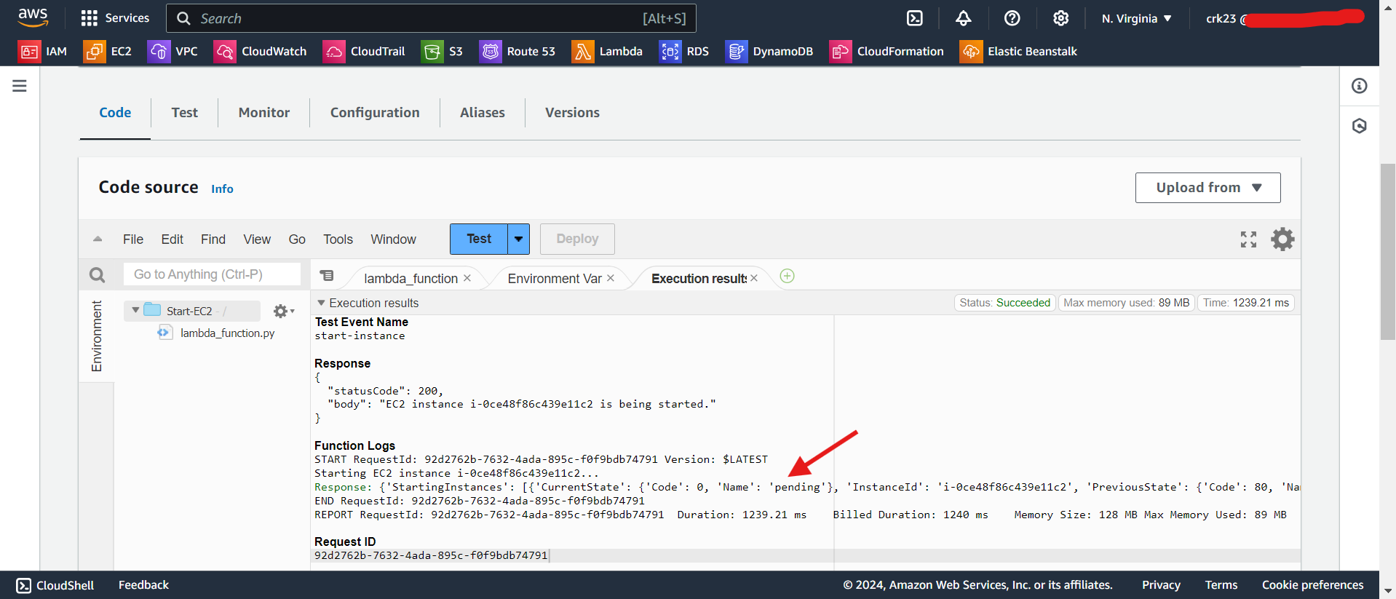

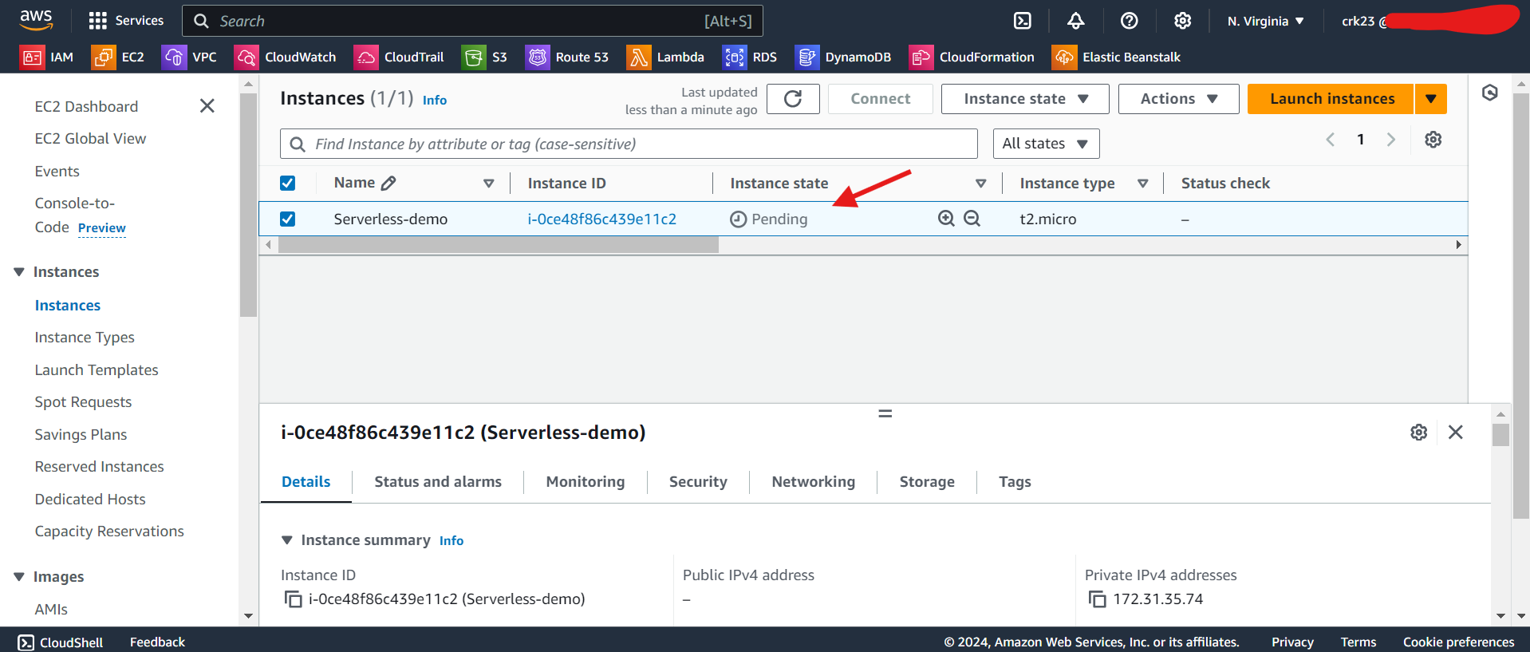

* EC2 Instance Started and Running successfully after executing the lambda function

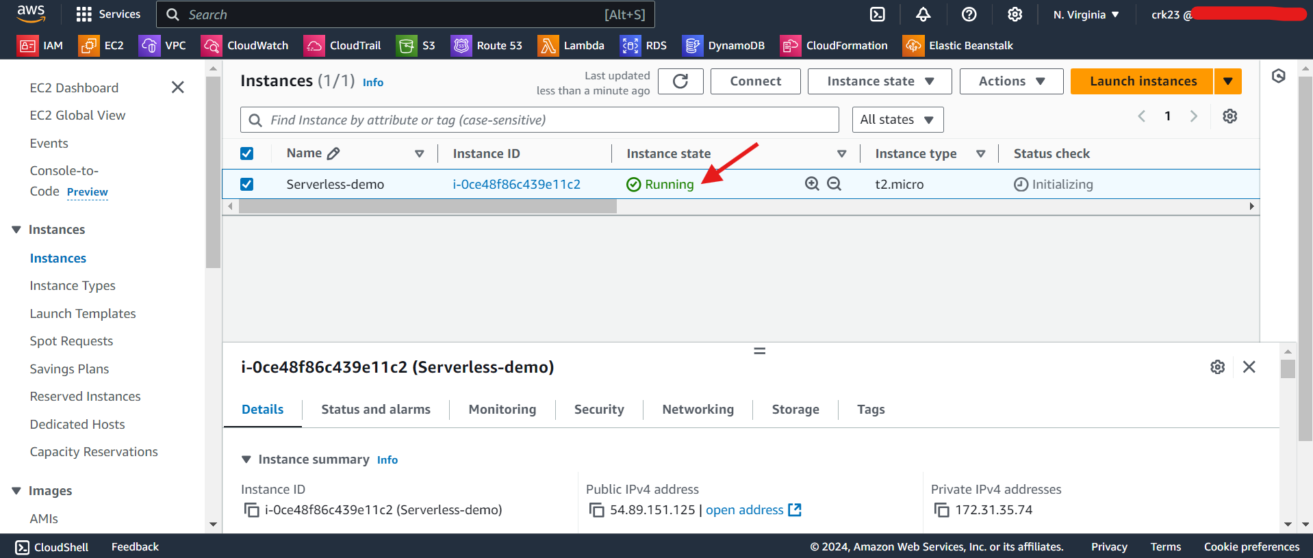

**STEP 4**

* Navigate to the Cloudwatch.
* Select **Events > Rules**.

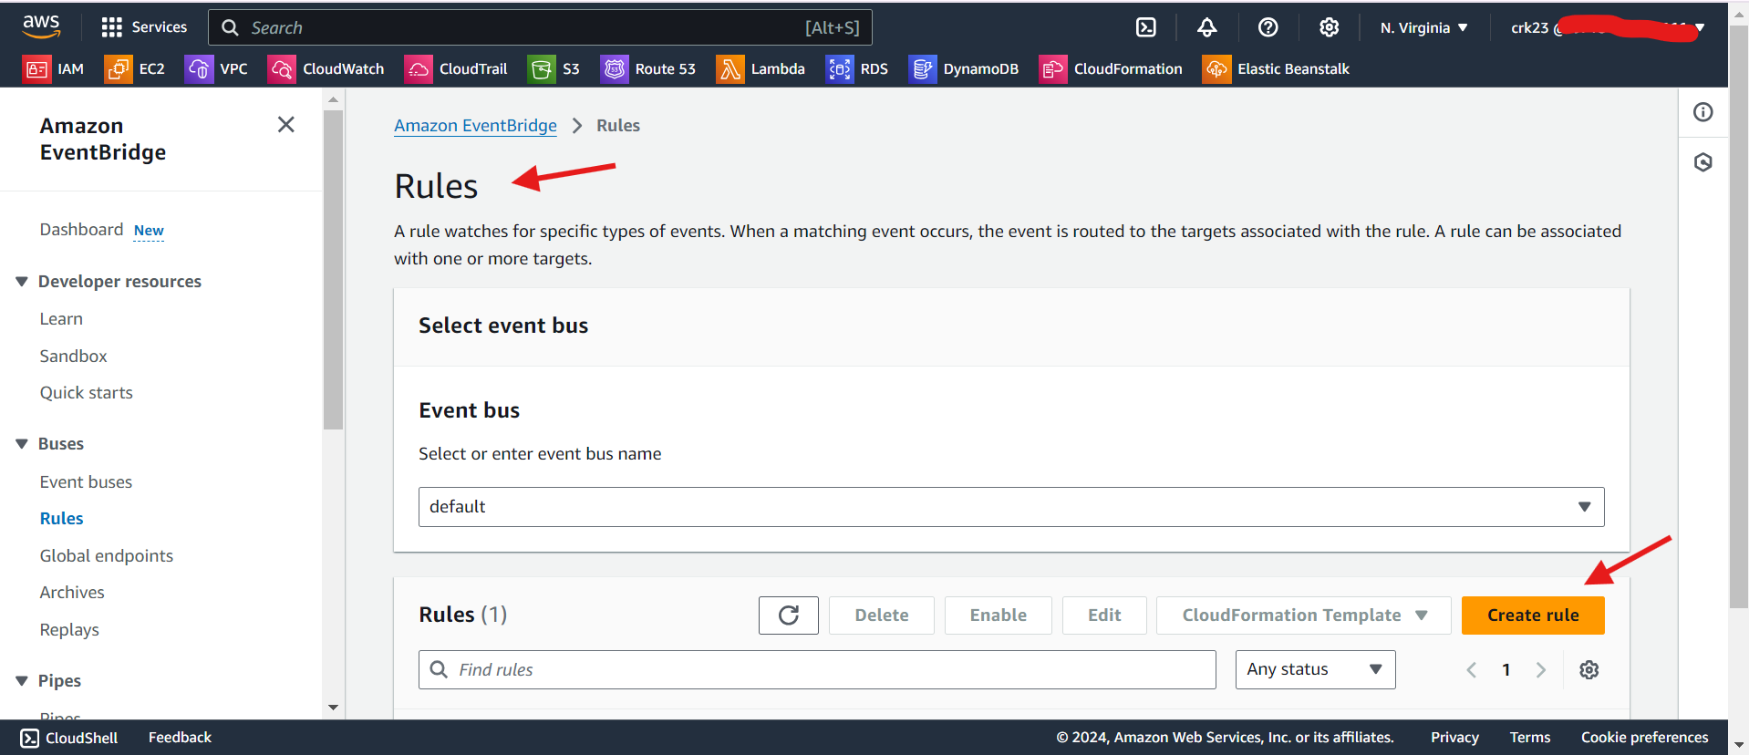

* Create a schedule for starting the lambda function to start at 9:00 A.M

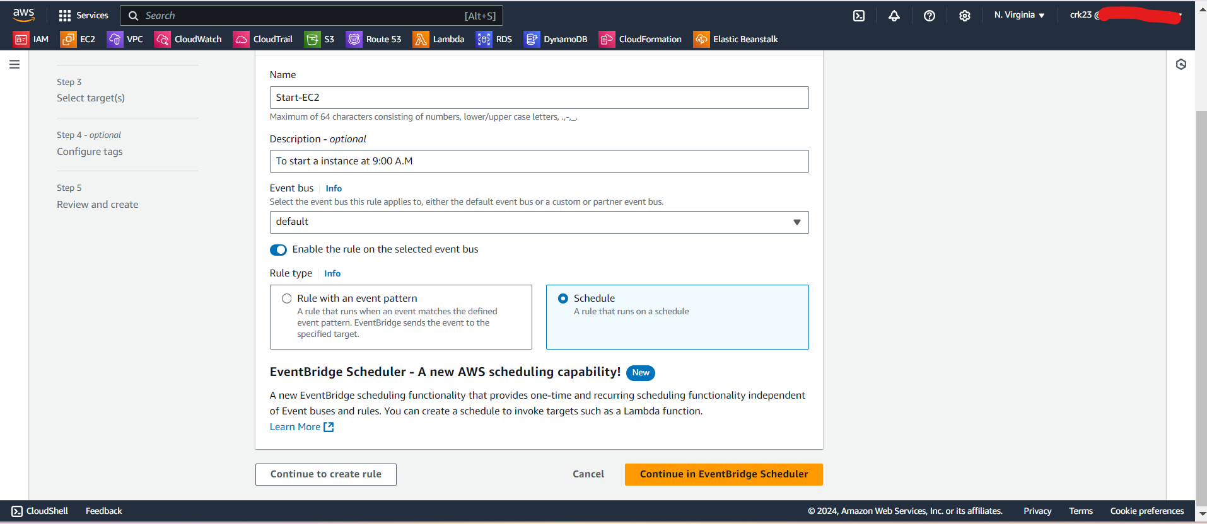

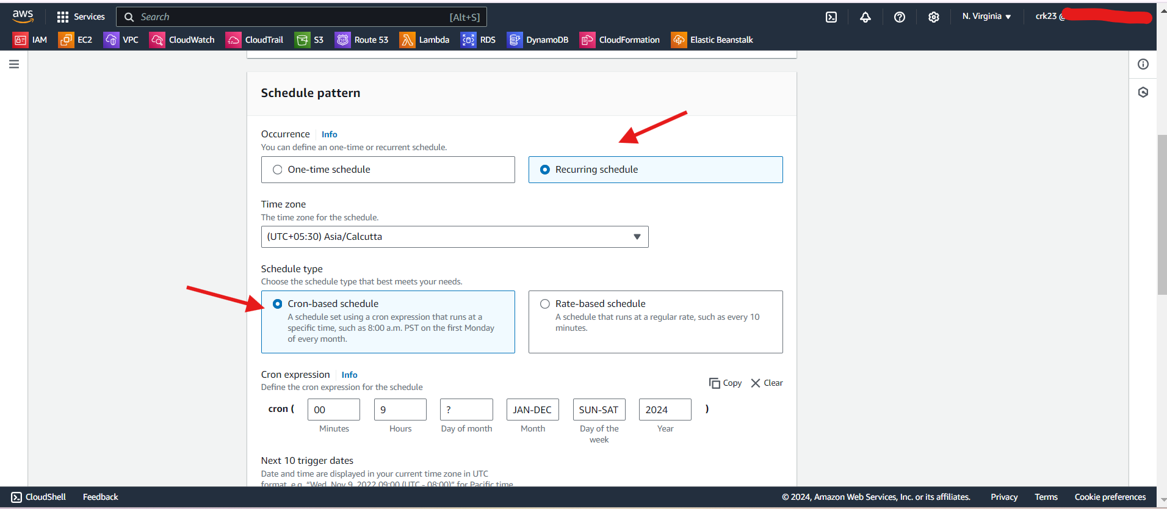

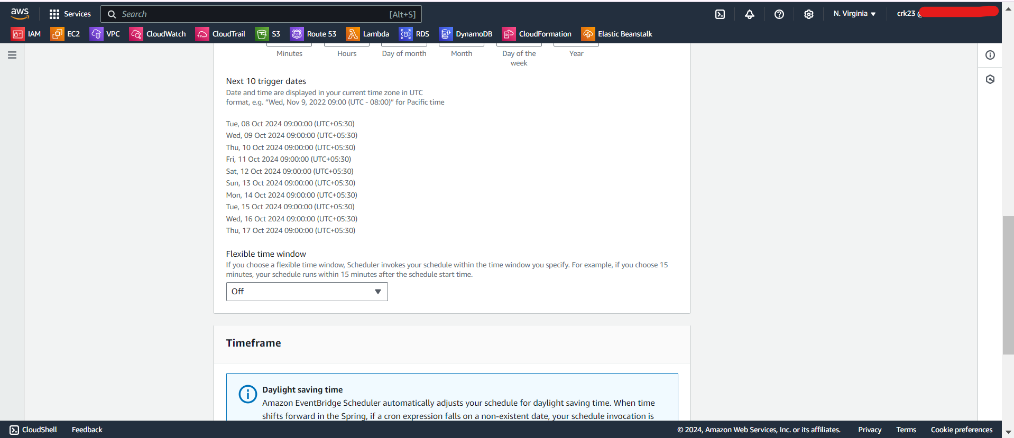

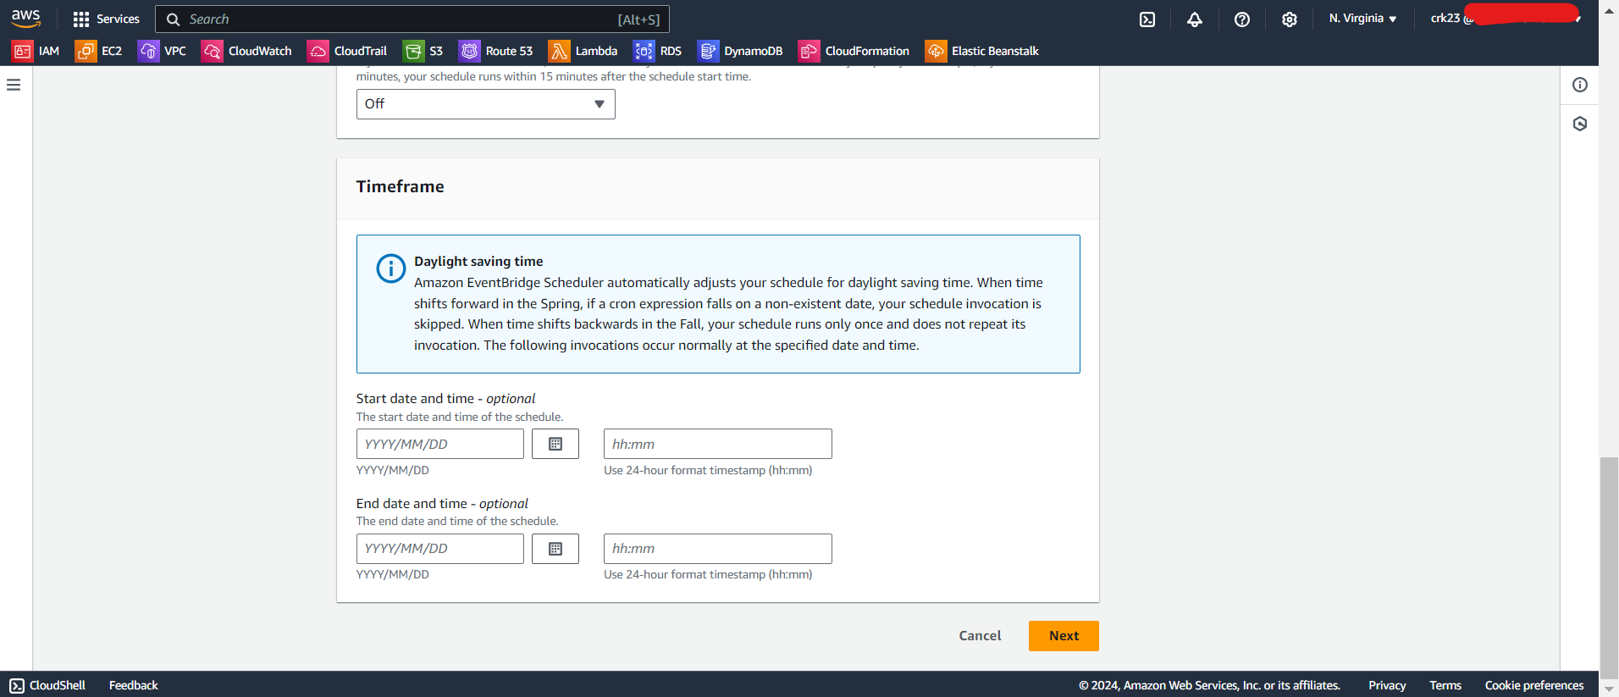

* Select Start-EC2 function.

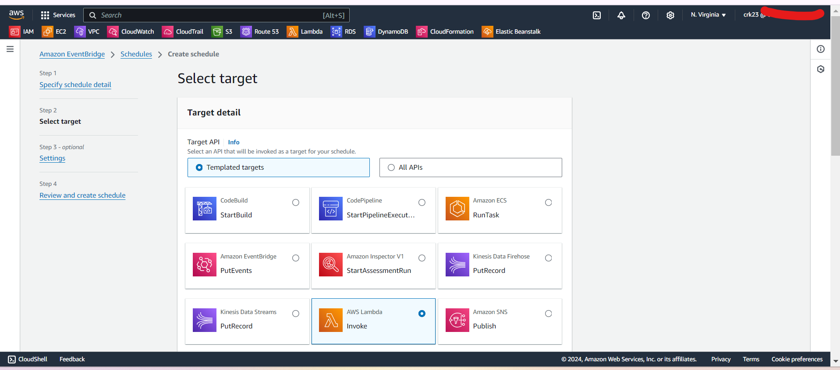

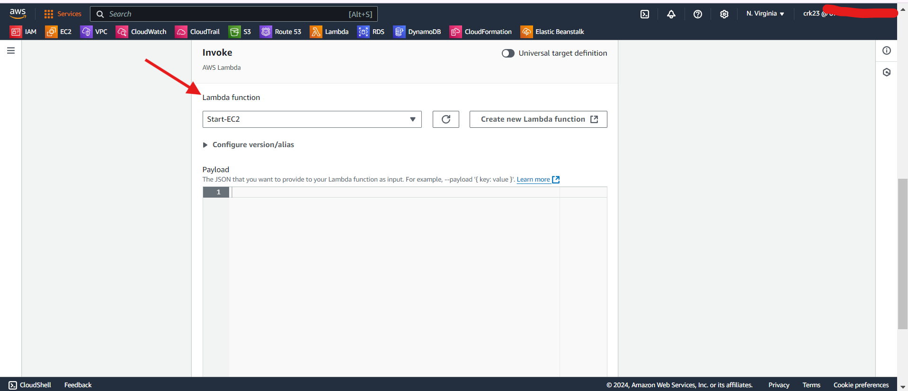

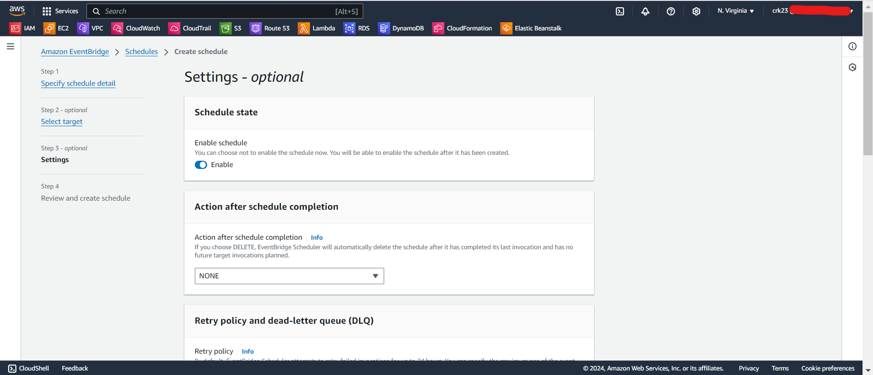

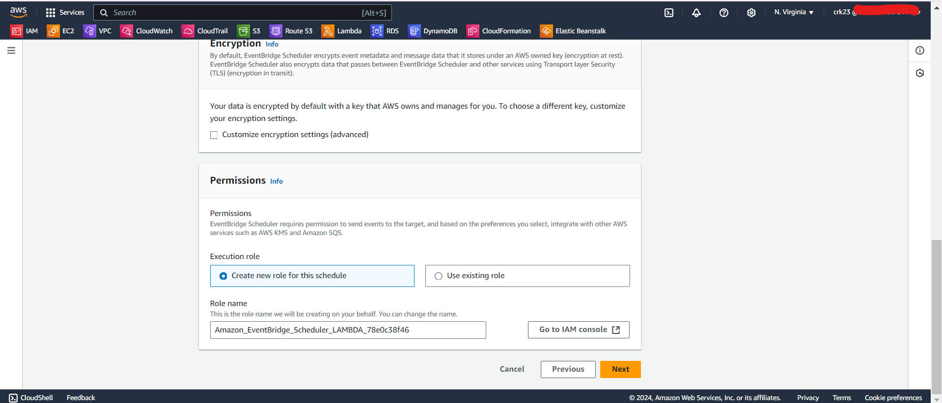

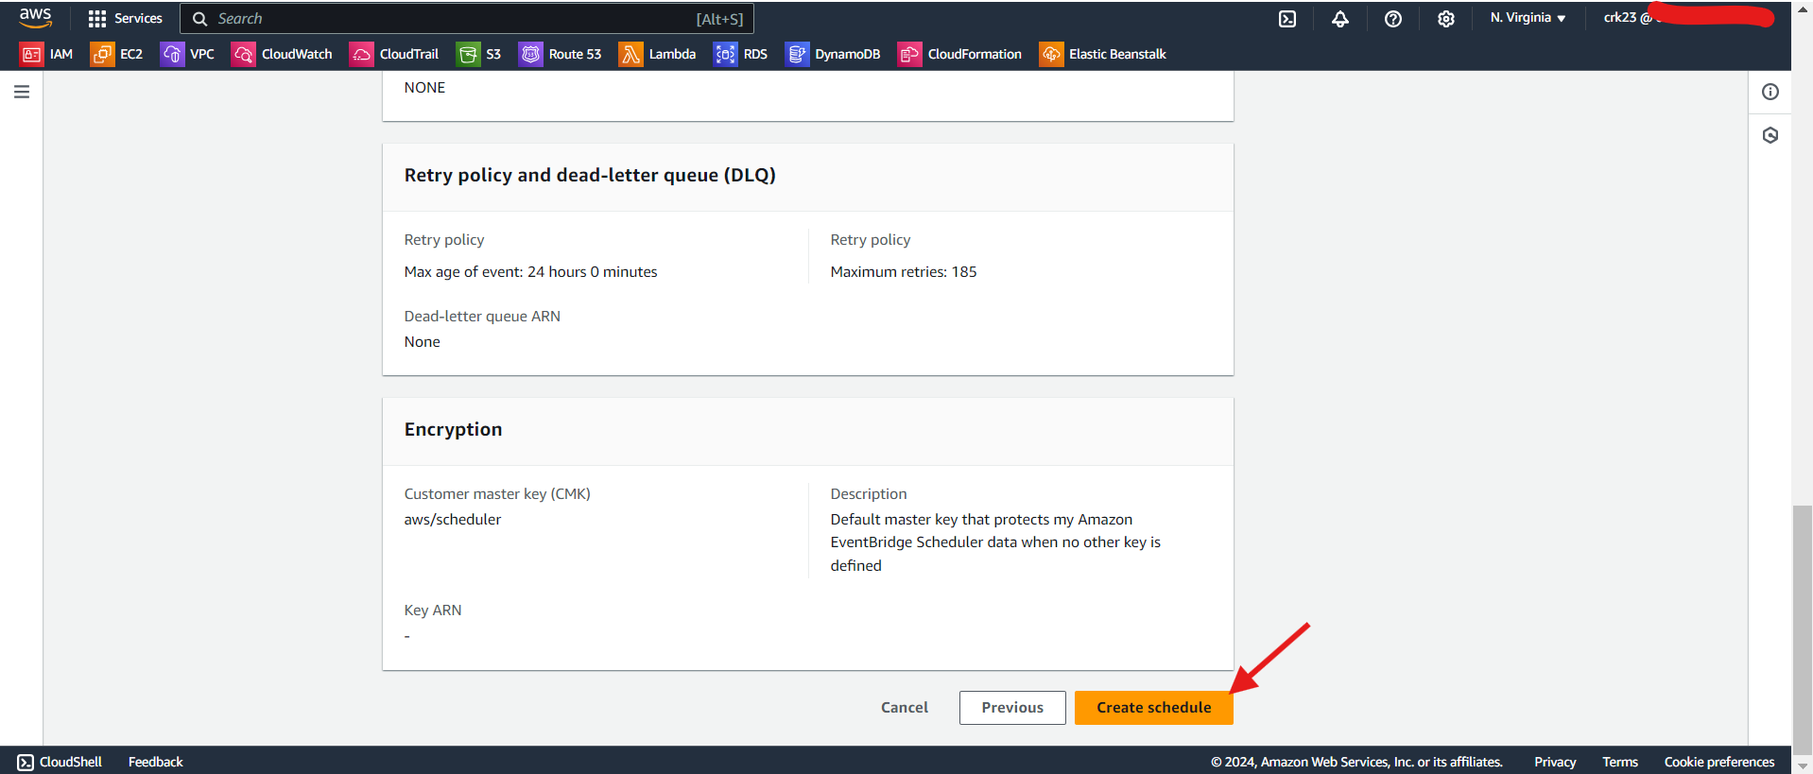

* Also create schedule for stopping the instance at 5:00 P.M

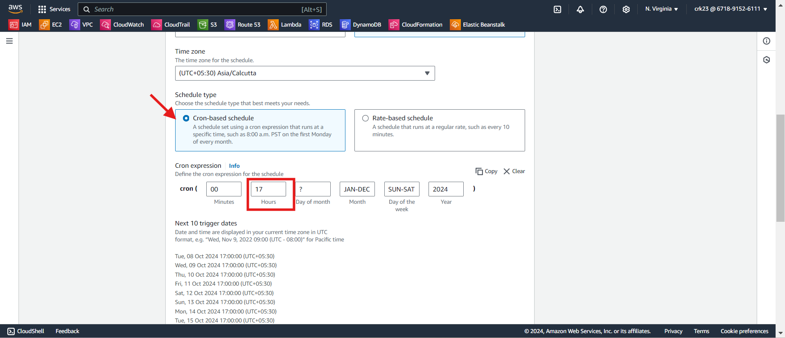

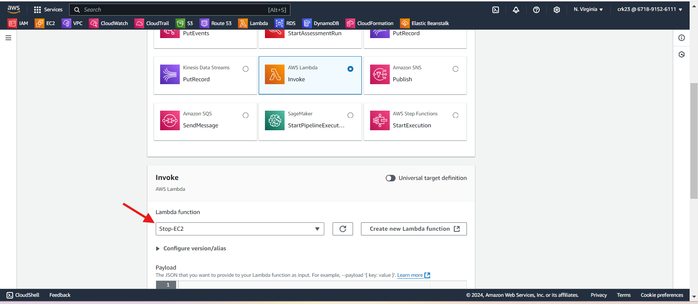

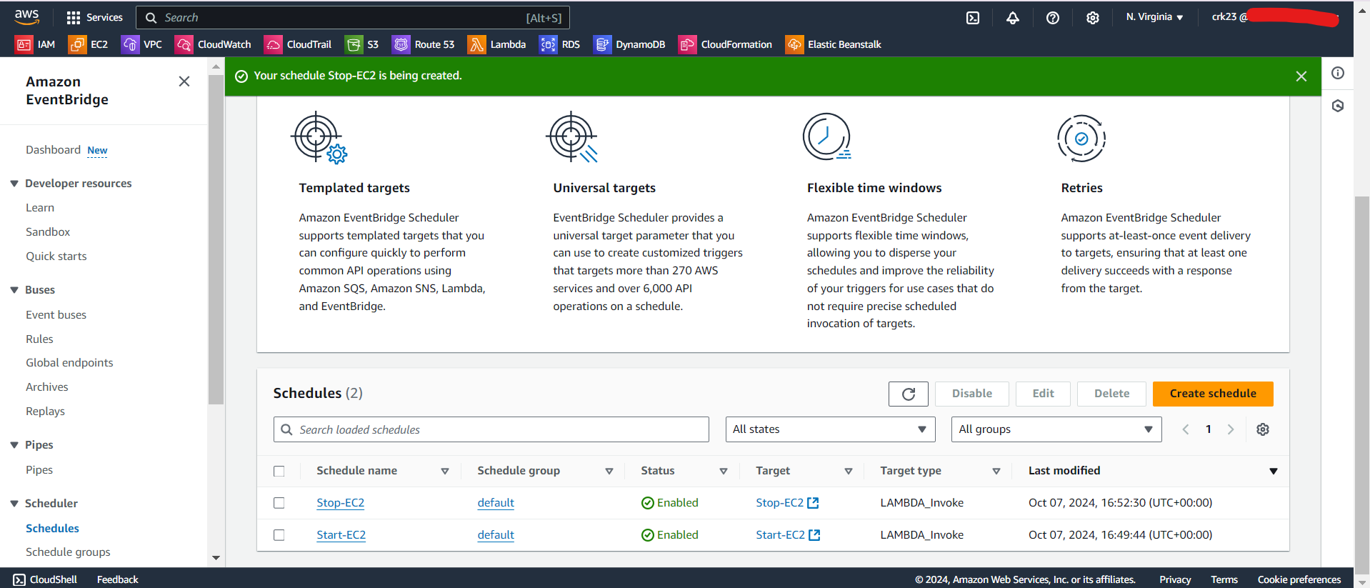

* Created two schedule to start instances at 9:00 A.M and to stop instances at 5:00 P.M daily.